|  |  |
| --- | --- |
| **BANK NAME** | BANK OF AMERICA |
| **ROUTING NUMBER (PAPER/ELECTRONIC)** | 111000025 |
| **ACCOUNT NUMBER** | 488103946557 |
| **CHECKING / SAVING ACCOUNT** | CHECKING |
| **ACCOUNT HOLDER** | AJAY KUMAR MANNEM |

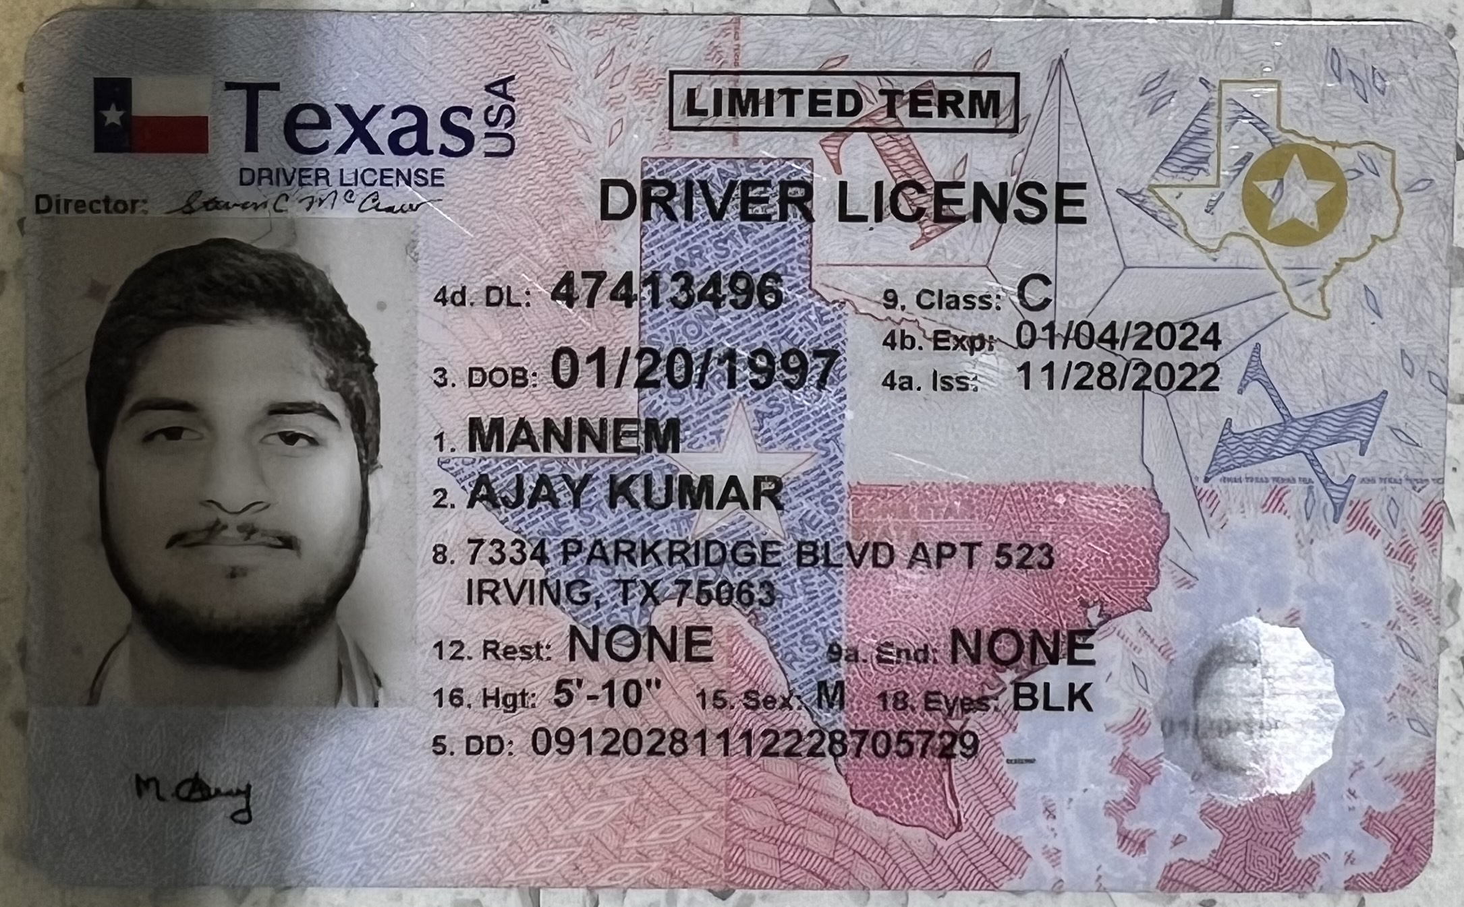

|  |  |  |
| --- | --- | --- |
| **DRIVING LICENSE/ STATE ISSUED PHOTO ID** | **TAXPAYER** | **SPOUSE** |
| **NUMBER** | 47413496 |  |
| **ISSUED STATE** | TEXAS |  |
| **ISSUED DATE** | 11/28/2022 |  |
| **EXPIRATION DATE** | 01/04/2024 |  |
| **TYPE OF ID (DRIVING LICENSE / STATE ISSUED ID/PASSPORT)** | DRIVING LICENSE |  |
| **REFERENCE ADDRESS OF INDIA** | 5-80 THIRUMALAPUR,CHITYALA,JAYASHANKARBHUPALPALLY-DIST,506356.TELANGANA STATE. |  |