Chase

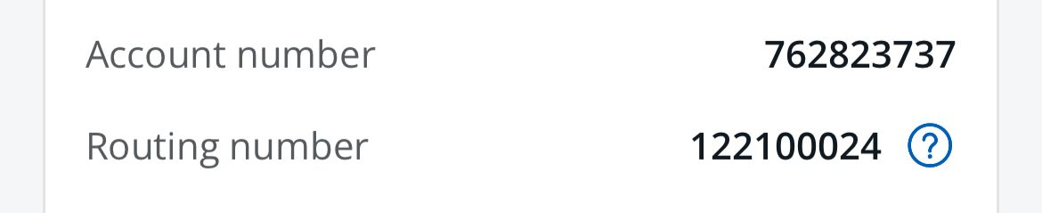

Checking

Kathyaini Rao