**SINGLE INFO FOR TAX RETURNS**

FIRST NAME:SIDDHESH

LAST NAME:KHANVILKAR

SSN NO:035 71 0242

OCCUPATION:MECHANICAL ENGINEER (FULL TIME)

DATE OF BIRTH:3RD DECEMBER 1996

MARITAL STATUS: SINGLE

E-MAIL ID:SIDDHESH.KHANVILKAR09@GMAIL.COM

PHONE NO:4693861845

CURRENT ADDRESS:13167 FOX HUNT LANE, APT 234, HERNDON, VA 20171

VISA STATUS: F1 (STEM OPT)

PORT OF ENTRY (YEAR):

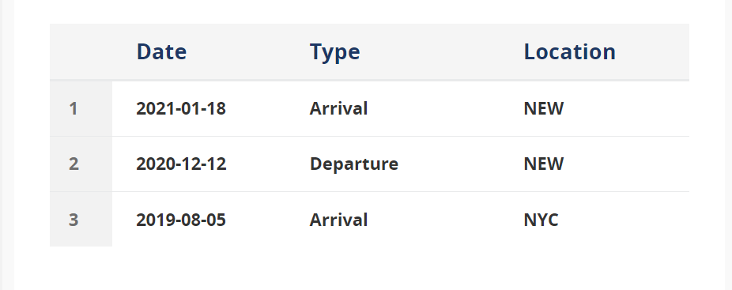

STATE OF RESIDENCY DURING 2022(WITH DATE): NON-RESIDENT ALIEN

OTHER DOCUMENTS LIKE 1098-T , 1099-B , 1099-INT,

2020- 6TH NOVEMBER =ARLINGTON, TEXAS

6TH NOV – 13TH MAY = HERNDON, VIRGINIA

13TH MAY – 12TH SEPT - SAN JOSE, CALIFORNIA

12TH SEPT - PRESENT = HERNDON, VIRGNIA

701/SATYAM, VASANT COMPLEX, MAHAVIR NAGAR, KANDIVALI WEST, MUMBAI 400067