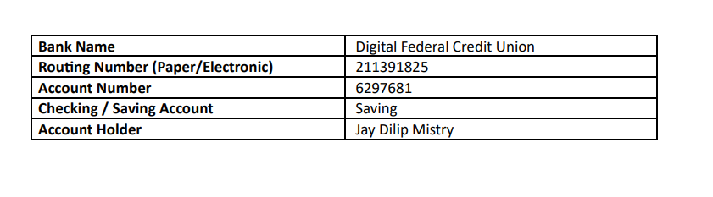

|  |  |  |
| --- | --- | --- |
| **Driving License/ State issued photo ID** | **Taxpayer** | **Spouse** |
| **Number** | 000042542308 | Single |
| **Issued State** | NC |  |
| **Issued Date** | 01/23/2023 |  |
| **Expiration date** | 10/29/2024 |  |
| **Type of ID (Driving License / State issued ID)** | Driving License |  |
|  |  |  |