**2022**

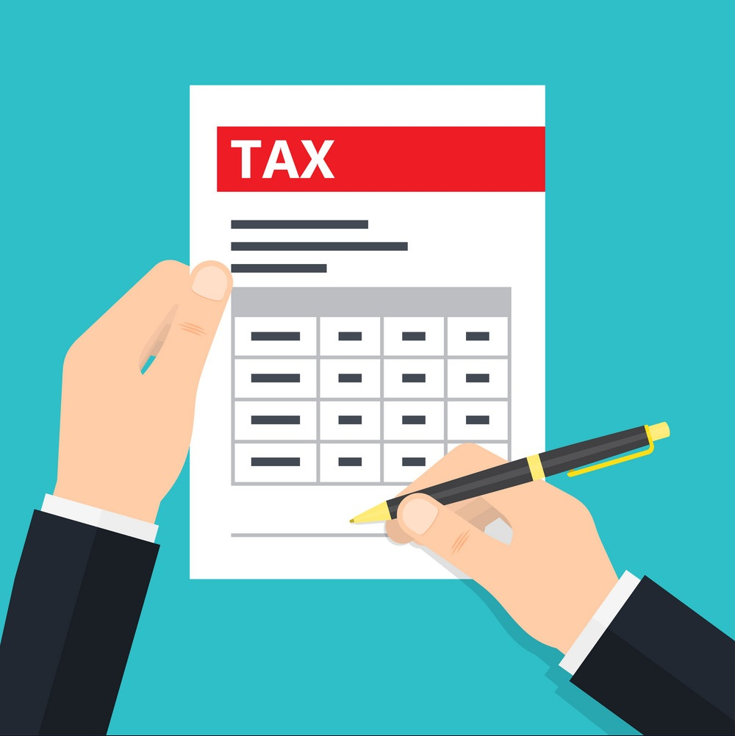

USA Tax Questioner

**BASIC INFORMATION**

|  |  |  |  |  |  |
| --- | --- | --- | --- | --- | --- |
|  | Tax Payer | Spouse | Dependent 1 | Dependent 2 | Dependent 3 |
| SSN Number | 304535829 | 283710371 | 491598127 |  |  |
| Active ITIN as per Record |  |  |  | 969923419 |  |
| First name as per SSN/Active ITIN Record’s | FAREEZUDDIN | SANA AMREEN | ANAM | ARHAAN |  |
| Middle Name | IMROZE |  | SIDDIQUA | SHARIFF |  |
| Last name as per SSN/ITIN | MOHAMMAD |  |  | MOHAMMAD |  |
| Date of Birth | JAN 4 1988 | OCT 21 1993 | AUG 25 2020 | 2 DEC 2016 |  |
| Marital Status | MARRIED | MARRIED | - | - |  |
| Occupation | CIVIL ENGINEER | - | - | - |  |
| Day Time Phone Number | 7247130124 |  |  |  |  |
| Email ID | [MFAREEZUDDIN@GMAIL.COM](mailto:MFAREEZUDDIN@GMAIL.COM) |  |  |  |  |
| Current Address | 12 TALBOT DR WESTBURY NY |  |  |  |  |
| First Port of Entry in US | ABU DHABI |  |  |  |  |
| No. of months stayed in US during 2022 | 11 MONTHS |  |  |  |  |
| Will you stay in US  For more than 6 months in 2023? (Y/N) | Y |  |  |  |  |
| Type of Visa | H1B |  |  |  |  |
| If change of Visa, provide Date of change MM/DD/YYYY |  |  |  |  |  |

**STATES RESIDED**

|  |  |  |  |  |
| --- | --- | --- | --- | --- |
|  | Primary Tax Payer | | Spouse / Dependents | |
| Tax Year | States Resided | Period of Stay (From Date & To Date) (MM/DD/YY) | States Resided | Period of Stay (From Date & To Date) (MM/DD/YY) |
| 2022 | NY | FULL | NY | FULL |
| 2020 |  |  |  |  |
| 2021 |  |  |  |  |

**EMPLOYMENT DETAILS**

|  |  |  |
| --- | --- | --- |
|  | Tax Payer | Spouse |
| Employer Name | AFRIDIASSOCIATES | - |
| Employment Start Date | 2 FEB 2018 |  |
| Employment Date | -DO- |  |

|  |  |
| --- | --- |
|  | Amount |
| Did you file the Iowa State Return last year? If yes mention the  Federal Refund amount | NO |
| Did you Itemized your last year’s Federal Tax return. If Yes, please mention All States Refund amount | NO |

**BANKS DETAILS**

|  |  |
| --- | --- |
| Bank Details | |
| Bank Name |  |
| Account Number |  |
| Routing Number |  |
| Type of Account |  |

|  |  |  |  |
| --- | --- | --- | --- |
| For Students | | | |
| Tax Payer | | **Dependant** | |
| Studies Completed (Yes/No) |  | Studies Completed (Yes/No) |  |
| If Yes then Date of Completion |  | If Yes then Date of Completion |  |
| If Pursuing Studies then Course of Study (Bachelors/Masters) |  | If Pursuing Studies then Course of Study (Bachelors/Masters) |  |
|
| Do you have 1098-T |  | Do you have 1098-T |  |

* Non Resident filer is exempt to claim Education credits and deductions

|  |  |
| --- | --- |
| Care Provider Name |  |
| Federal EIN |  |
| Care Provider Full Address |  |
| Amount You paid |  |
| Amount Reimbursed by your Employer |  |

**DEPENDENT CARE EXPENSES**

**FOREIGN INCOME**

|  |  |  |  |
| --- | --- | --- | --- |
|  | Foreign Salary Income | Interest Income | Dividend Income |
| Amount you Earned |  |  |  |
| Taxes You Paid |  |  |  |

**RENTAL INCOME**

|  |  |  |
| --- | --- | --- |
|  | US Rental Income | Foreign Rental Income |
| Property Type? (Residential/Commercial) |  |  |
| Location/Address |  |  |
| Specify the following: |  |  |
| Number of months rented in year 2022 |  |  |
| Number of months you used for personal purpose |  |  |
| Date this property was purchased (mm/dd/yy) |  |  |
| Cost of the property |  |  |

**RENTAL EXPENSES**

|  |  |  |
| --- | --- | --- |
|  | US Rental Expenses | Foreign Rental Expenses |
| Mortgage Interest Paid |  |  |
| Repairs |  |  |
| Maintenance |  |  |
| Legal and professional fees |  |  |
| Supplies |  |  |
| Commission |  |  |
| Insurance |  |  |
| Other Expenses |  |  |

**HOME MORTGAGE DETAILS**

|  |  |  |
| --- | --- | --- |
| Interest & Tax Paid | Taxpayer Amount | Spouse Amount |
| Home Mortgage Interest & Points (For property in US) - Provide Form 1098 - Enter only the Interest Amount not your EMI |  |  |
| Property Taxes (For property in US) |  |  |
| Home Mortgage Interest (For property in India/Foreign Country) - Please mention Bank Name, Bank Address & Interest Amount in USD - Provide only Interest Amount not your EMI |  |  |
| Property Taxes (For property in India) |  |  |

**RENT YOU PAID (**Note: “Pre-Tax contribution” will not be considered into computation)**

|  |  |
| --- | --- |
| States | Amount Paid |
| New Jersey |  |
| Indiana |  |
| Wisconsin |  |
| Massachusetts` |  |
| Minnesota (Certificate of rent paid required) |  |

**OTHER EXPENSES**

|  |  |  |  |
| --- | --- | --- | --- |
|  | Tax Payer | Spouse | Amount Reimbursed by the Employer |
| Medical Expenses |  |  |  |
| Health Saving Account |  |  |  |
| Individual Retirement Saving Arrangement’s (IRA) |  |  |  |
| New Car Sales & Exercise Taxes |  |  |  |
| Charity Contributions |  |  |  |
| Residential Energy product |  |  |  |
| Educator Expenses |  |  |  |
| Penalty on early withdrawal on saving accounts |  |  |  |
| Student Loan Interest Paid |  |  |  |

**FBAR & FATCA**

|  |  |  |
| --- | --- | --- |
|  | FBAR | FATCA |
| Did you have more than $10,000 in your Foreign Accounts at any time during the Tax Year 2022? |  |  |
| Did you have more than $50,000 in your Foreign Accounts at any time during the Tax Year 2022? |  |  |
| Did you Report or file FBAR or FATCA in TY 2020? (Yes/No) |  |  |

Note:

The United States persons including a citizen, resident, corporation, partnership, Limited Liability Company, trust and estate, must file an FBAR to report:   
1. A financial interest in or signature or other authority over at least one financial account located outside the United States if  
2. The aggregate value of those foreign financial accounts exceeded $10,000 at any time during the calendar year reported.

If the amount exceeds $50,000 for Single Filer and $100,000 for a Joint filer then FATCA must be reported along with the Tax returns. Please call our office 9AM to 6PM for more details on FBAR/FATCA

To know more please refer to the link (https://bsaefiling.fincen.treas.gov/docs/FBAR_EFILING_FAQ.pdf)

|  |
| --- |
| Any additional information to the Tax Preparer |
|  |

REFERRALS

|  |  |  |
| --- | --- | --- |
| Name | Contact Number | Email Id |
|  |  |  |
|  |  |  |
|  |  |  |
|  |  |  |