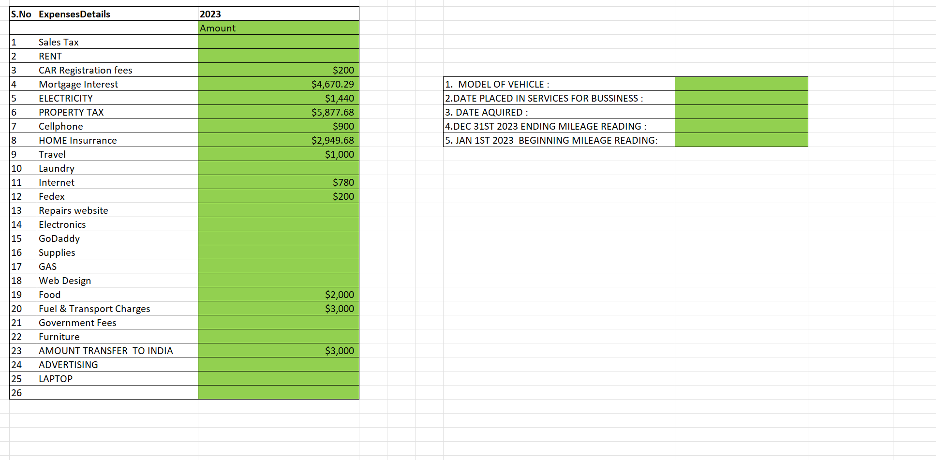

NE

H14041825

10/18/2022

12/26/2024