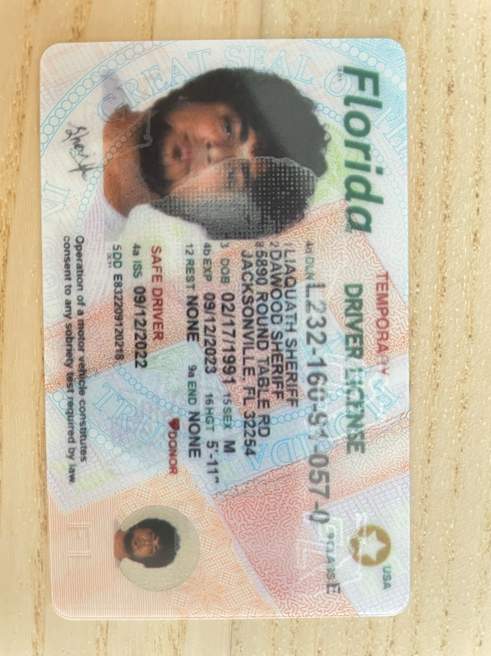

|  |  |
| --- | --- |
| **Bank Name** | Bank of America |
| **Routing Number (Paper/Electronic)** | 021200339 |
| **Account Number** | 381055088466 |
| **Checking / Saving Account** | Checking |
| **Account Holder** | Dawood sheriff |

**Pls. provide the below details to E - File your taxes with IRS and state departments.**

1. **If Filing status is Single, provide only your ID proof**
2. **If Filing Jointly, provide you and your Spouse ID proof**

|  |  |  |
| --- | --- | --- |
| **Driving License/ State issued photo ID** | **Taxpayer** | **Spouse** |
| **Number** | L232160910570 |  |
| **Issued State** | FL |  |
| **Issued Date** | 09/12/2022 |  |
| **Expiration date** | 09/12/2023 |  |
| **Type of ID (Driving License / State issued ID)** | Driving license |  |
|  |  |  |