**Paper Filing Instructions for applying ITIN for Spouse**

**Steps to be followed** –

1. **Download the Attached PDF Federal tax documents**
2. **Print them on ONE side page only and DO NOT STAPLE them.**
3. **You and Your Spouse have to sign on Form 1040 page 2. See below image**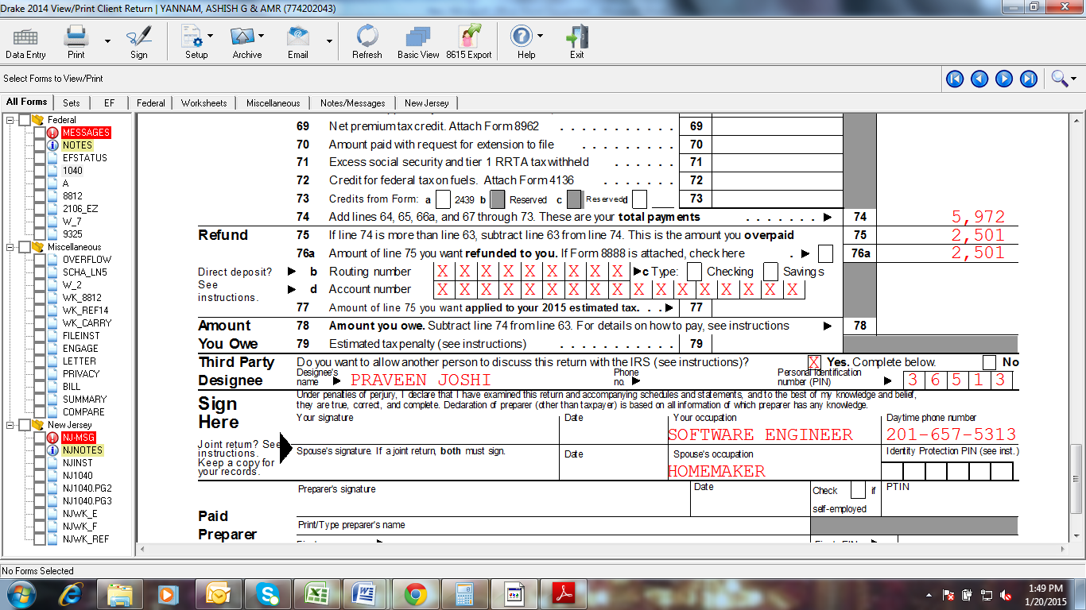
4. **Attach Form W7 (ITIN Application) & your Spouse has to Sign it. See below image**

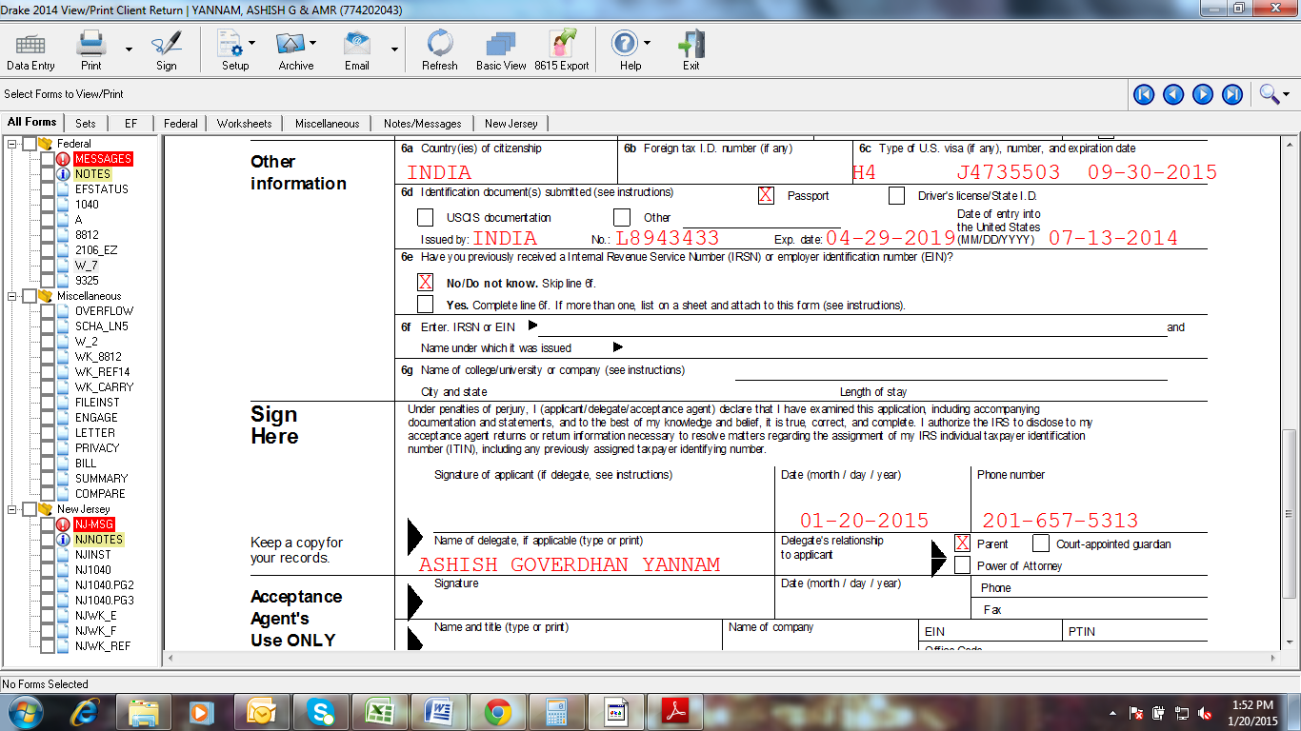

1. **Attach a copy of all W2’s of the year 2022.**
2. **You and Your Spouse have to sign on Form 6013G.**
3. **POST the ENTIRE federal document to the below IRS Address**.

**BY USPS**

INTERNAL REVENUE SERVICE  
ITIN OPERATION

P.O.BOX 149342

Austin, TX 78714-9342

**BY PRIVATE DELIVERY**

INTERNAL REVENUE SERVICES

ITIN OPERATIONS

MAIL STOP 6090-AUSC

3651 S INTERREGIONAL, HWY 35

AUSTIN, TEXAS 78741-0000

**Note: Cross check your Bank details once again.**