**Paper Filing Instructions for applying ITIN for Spouse**

**Steps to be followed** –

1. **Download the Attached PDF Federal tax documents**
2. **Print them on ONE side page only and DO NOT STAPLE them.**
3. **You and Your Spouse have to sign on Form 1040 page 2. See below image**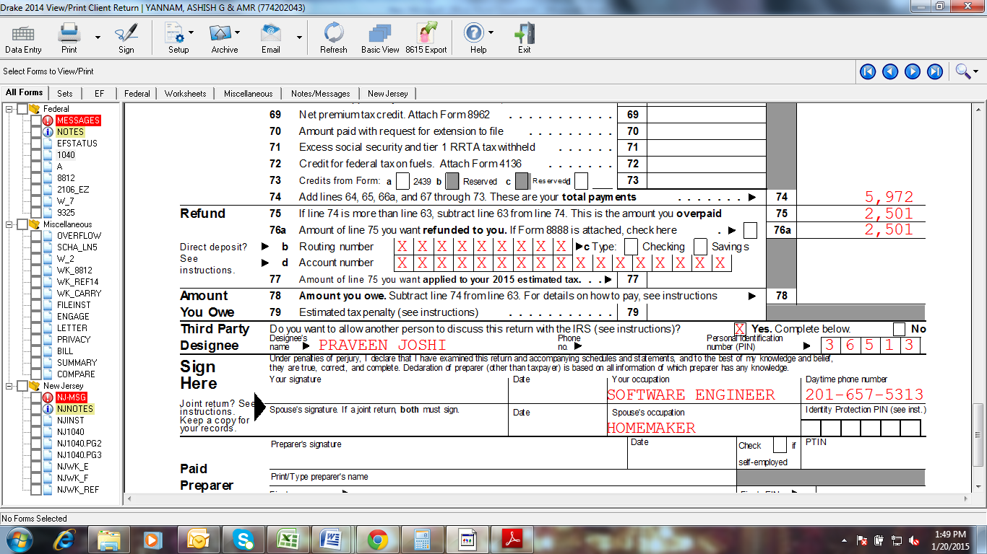
4. **Attach Form W7 (ITIN Application) & your Spouse has to Sign it. See below image**

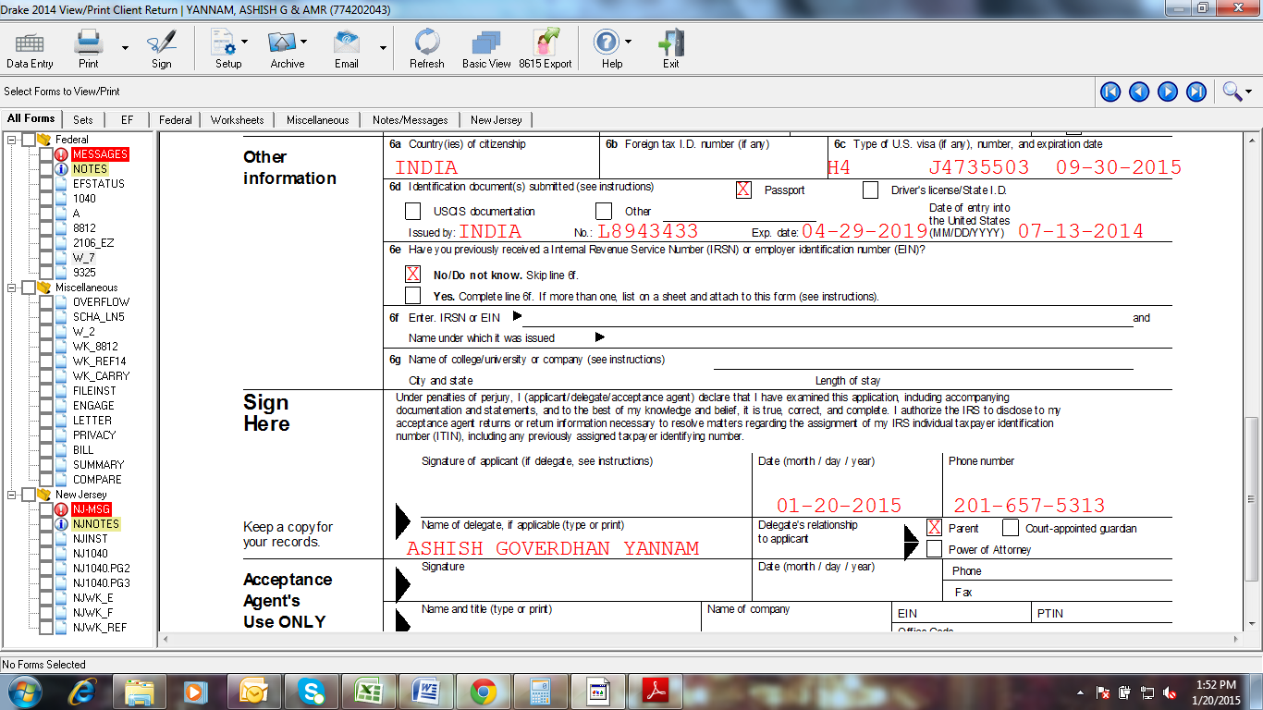

1. **Attach a copy of all W2’s of the year 2022.**
2. **Schedule an Appoint with IRS on 844-545-5640**
3. **Visit IRS Office along with your Spouse and Original Passport, IRS office address is provided in the Email.**

**Note: Cross check your Bank details once again.**