Form

**8879**

(

Rev. January

2021)

Department of the Treasury

Internal Revenue Service

IRS

*e-file*

Signature Authorization

a

ERO must obtain and retain completed Form 8879.

a

Go to

*www.irs.gov/Form8879*

for the latest information.

OMB No. 1545-0074

Submission Identification Number (SID)

F

|  |  |  |  |
| --- | --- | --- | --- |
| Taxpayer’s name | |  | Social security number |
| KOUSHIK JILLA | |  | 684-02-8706 |
| Spouse’s name | |  | Spouse’s social security number |
| Part I | Tax Return Information — Tax Year Ending December 31, | 2023 (Enter year you are authorizing.) | |

Enter whole dollars only on lines 1 through 5.

Note: Form 1040-SS filers use line 4 only. Leave lines 1, 2, 3, and 5 blank.

|  |  |  |  |
| --- | --- | --- | --- |
| 1 Adjusted gross income . . . . . . . . . . . . . . . . . . . . . . . . . . 2 Total tax . . . . . . . . . . . . . . . . . . . . . . . . . . . . . . .   1. Federal income tax withheld from Form(s) W-2 and Form(s) 1099 . . . . . . . . . . . . . 2. Amount you want refunded to you . . . . . . . . . . . . . . . . . . . . . . 5 Amount you owe . . . . . . . . . . . . . . . . . . . . . . . . . . . . | | 1 | 39,703. |
| 2 | 2,885. |
| 3 | 3,880. |
| 4 | 995. |
| 5 |  |
| Part II | Taxpayer Declaration and Signature Authorization (Be sure you get and keep a copy of your return) | | |

Under penalties of perjury, I declare that I have examined a copy of the income tax return (original or amended) I am now authorizing, and to the best of my knowledge and belief, it is true, correct, and complete. I further declare that the amounts in Part I above are the amounts from the income tax return (original or amended) I am now authorizing. I consent to allow my intermediate service provider, transmitter, or electronic return originator (ERO) to send my return to the IRS and to receive from the IRS (a) an acknowledgement of receipt or reason for rejection of the transmission, (b) the reason for any delay in processing the return or refund, and (c) the date of any refund. If applicable, I authorize the U.S. Treasury and its designated Financial Agent to initiate an ACH electronic funds withdrawal (direct debit) entry to the financial institution account indicated in the tax preparation software for payment of my federal taxes owed on this return and/or a payment of estimated tax, and the financial institution to debit the entry to this account. This authorization is to remain in full force and effect until I notify the U.S. Treasury Financial Agent to terminate the authorization. To revoke (cancel) a payment, I must contact the U.S. Treasury Financial Agent at 1-888-353-4537. Payment cancellation requests must be received no later than 2 business days prior to the payment (settlement) date. I also authorize the financial institutions involved in the processing of the electronic payment of taxes to receive confidential information necessary to answer inquiries and resolve issues related to the payment. I further acknowledge that the personal identification number (PIN) below is my signature for the income tax return (original or amended) I am now authorizing and, if applicable, my Electronic Funds Withdrawal Consent.

|  |  |  |  |  |
| --- | --- | --- | --- | --- |
| 2 | 8 | 7 | 0 | 6 |

Taxpayer’s PIN: check one box only

I authorize GLOBAL TAXES LLC to enter or generate my PIN as my

Enter five digits, but

ERO firm name don’t enter all zeros signature on the income tax return (original or amended) I am now authorizing.

I will enter my PIN as my signature on the income tax return (original or amended) I am now authorizing. Check this box only if you are entering your own PIN and your return is filed using the Practitioner PIN method. The ERO must complete Part III below.

Your signature: *Koushik jilla* Date : 02/16/2024

Spouse’s : Koushik Jilla PIN: check one box only

as my

I authorize to enter or generate my PIN

ERO firm name Enter five digits, but

signature on the income tax return (original or amended) I am now authorizing. don’t enter all zeros

I will enter my PIN as my signature on the income tax return (original or amended) I am now authorizing. Check this box only if you are entering your own PIN and your return is filed using the Practitioner PIN method. The ERO must complete Part III below.

Spouse’s signature a Date a

Practitioner PIN Method Returns Only—continue below

|  |  |  |  |  |  |  |  |  |  |  |  |  |  |
| --- | --- | --- | --- | --- | --- | --- | --- | --- | --- | --- | --- | --- | --- |
| Part III | Certification and Authentication — Practitioner PIN Method Only |  |  |  |  |  |  |  |  |  |  |  | |
| ERO’s EFIN/PIN. Enter your six-digit EFIN followed by your five-digit self-selected PIN. | | 2 | 2 | 2 | 4 | 9 | 6 | 0 | 8 | 2 | 7 | 1 |  |

Don’t enter all zeros

I certify that the above numeric entry is my PIN, which is my signature for the electronic individual income tax return (original or amended) I am now authorized to file for tax year indicated above for the taxpayer(s) indicated above. I confirm that I am submitting this return in accordance with the requirements of the Practitioner PIN method and Pub. 1345, Handbook for Authorized IRS *e-file* Providers of Individual Income Tax Returns.

|  |  |
| --- | --- |
| ERO’s signature a | Date a |
|  | ERO Must Retain This Form — See Instructions Don’t Submit This Form to the IRS Unless Requested To Do So |

For Paperwork Reduction Act Notice, see your tax return instructions. **BAA** REV 02/11/24 PRO Form 8879 (Rev. 01-2021)

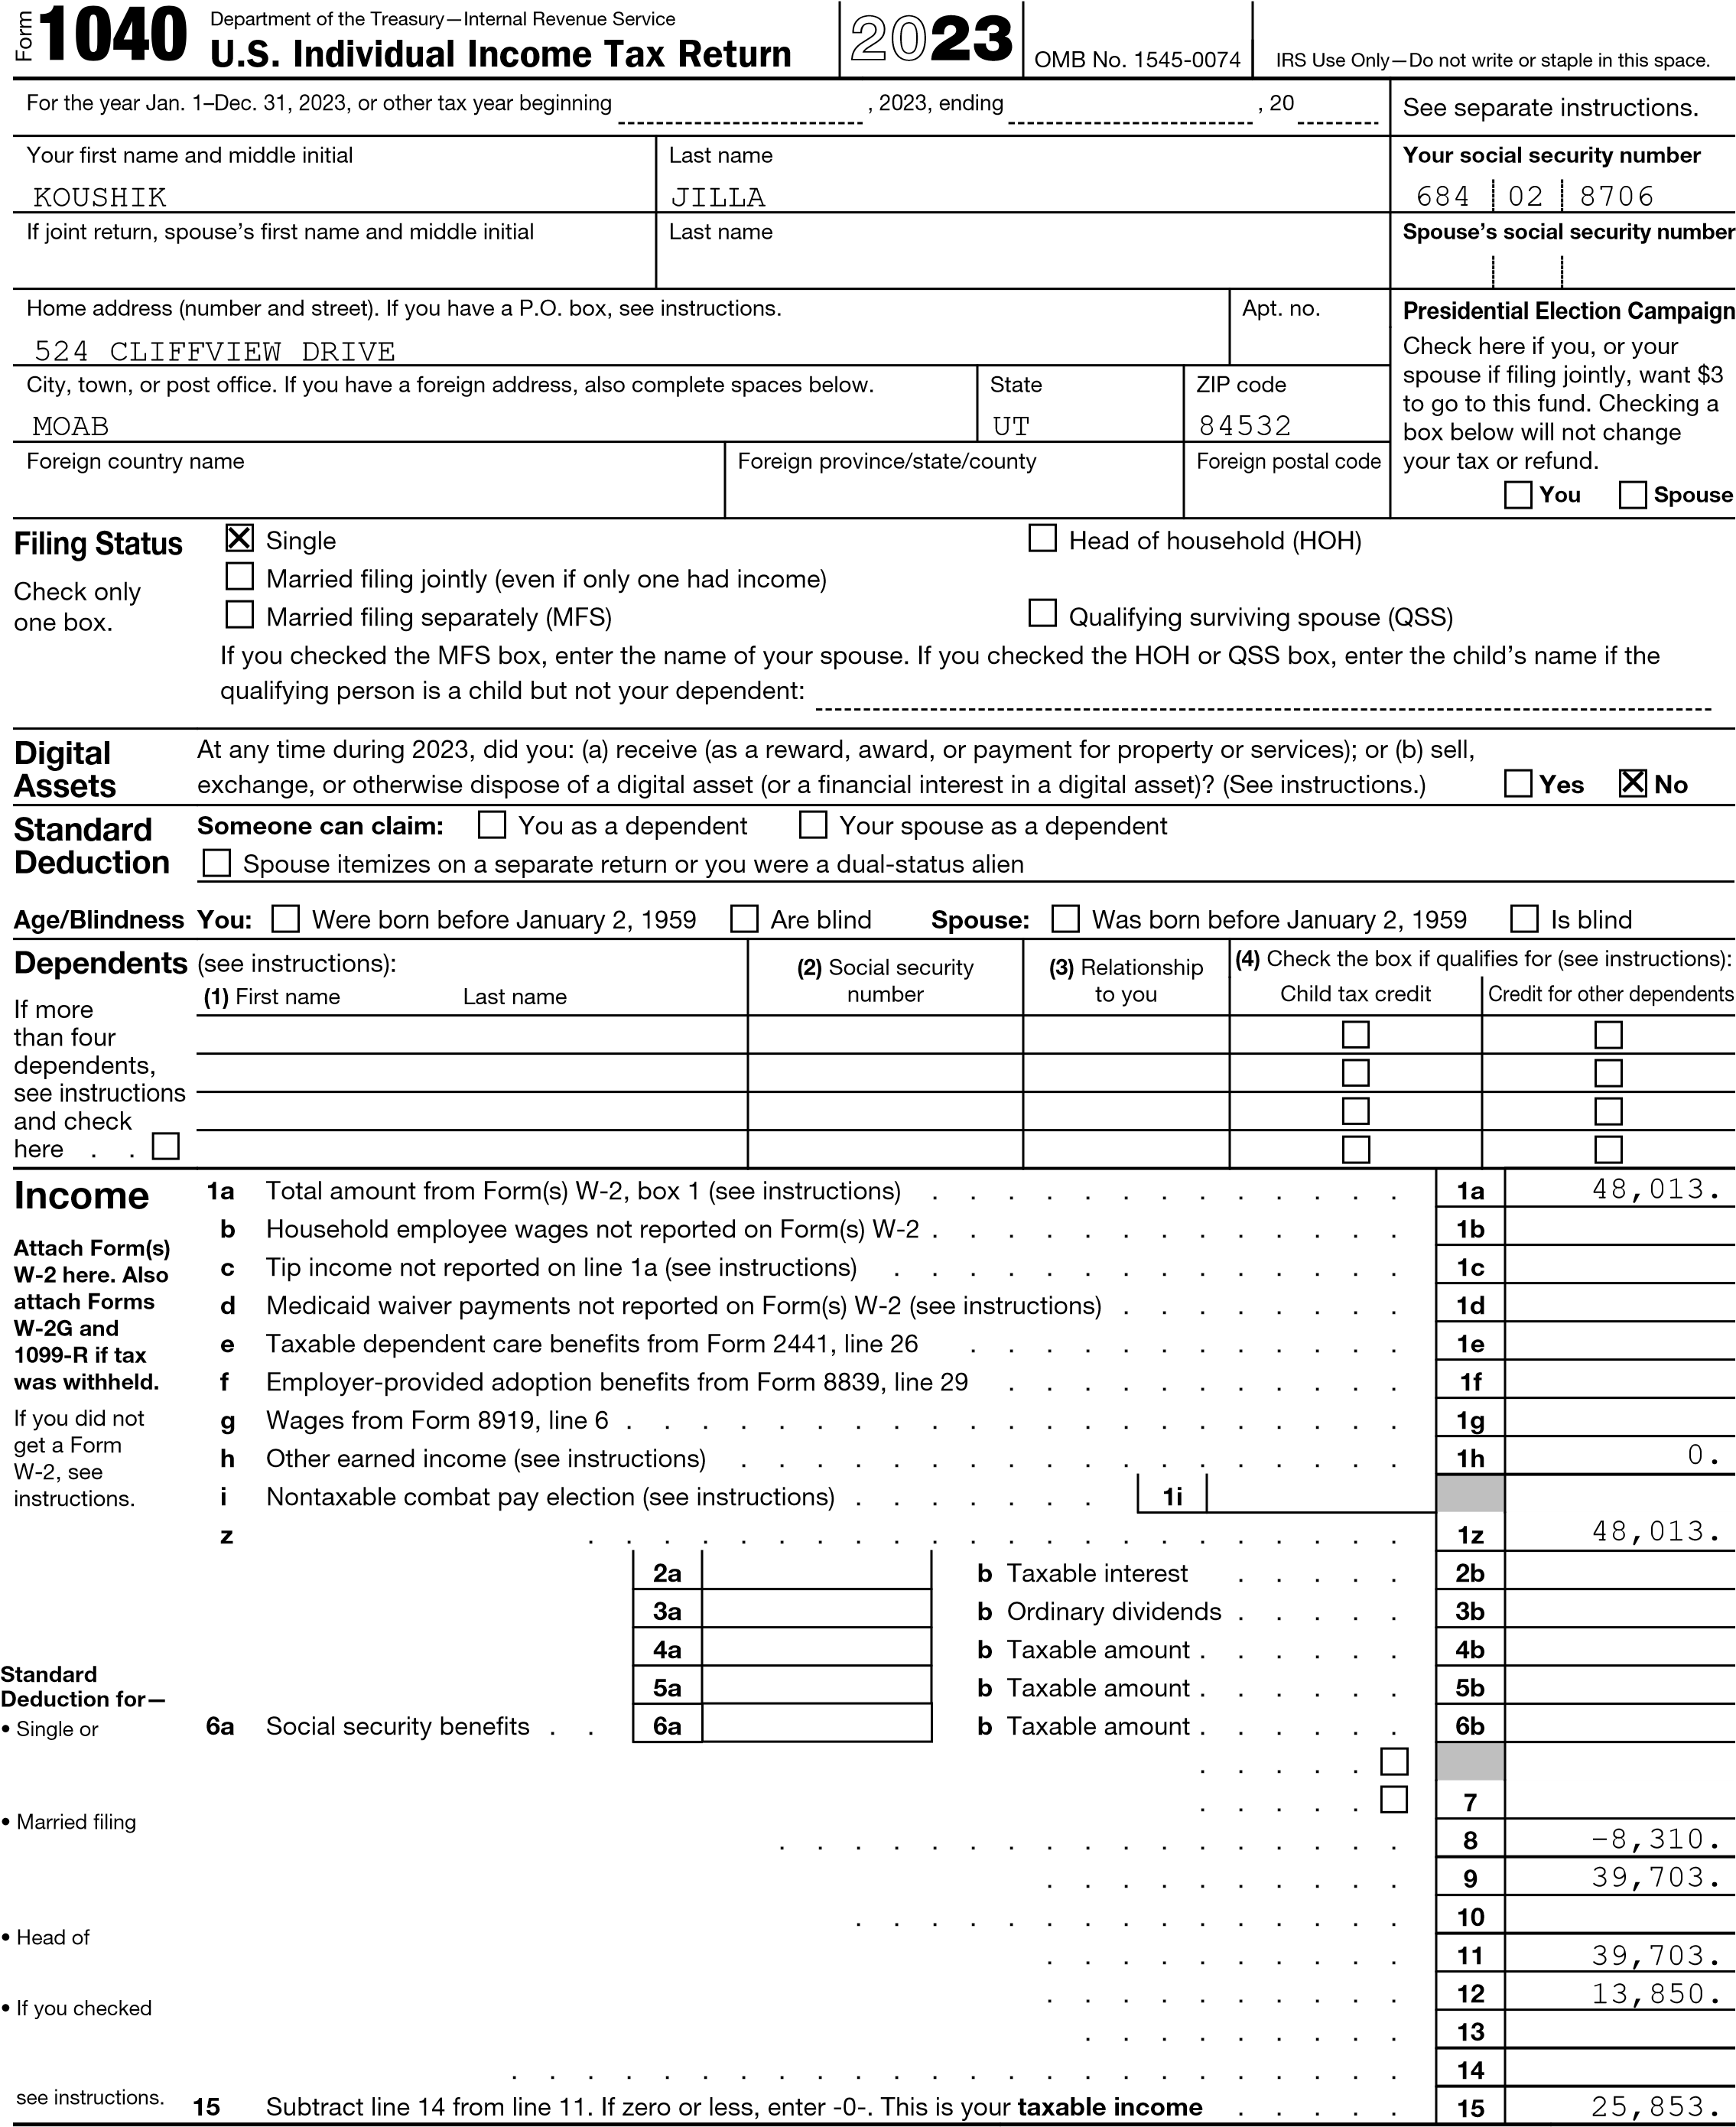 . . .

. . .

. . .

Add lines 1a through 1h . . . . . . . . . . .

Attach Sch. B 2a Tax-exempt interest . . . if required. 3a Qualified dividends . . . 4a IRA distributions . . . . 5a Pensions and annuities . .

Married filing

separately, c If you elect to use the lump-sum election method, check here (see instructions) .

$13,850 7 Capital gain or (loss). Attach Schedule D if required. If not required, check here jointly or 8 Additional income from Schedule 1, line 10 . . . . . .

Qualifying

surviving spouse, 9 Add lines 1z, 2b, 3b, 4b, 5b, 6b, 7, and 8. This is your total income .

$27,700 10 Adjustments to income from Schedule 1, line 26 . . . .

household, 11 Subtract line 10 from line 9. This is your adjusted gross income

$20,800

12 Standard deduction or itemized deductions (from Schedule A)

any box under 13 Qualified business income deduction from Form 8995 or Form 8995-A .

*Standard*

*Deduction*, 14 Add lines 12 and 13 . . . . . . . . . . . . . 13,850.

For Disclosure, Privacy Act, and Paperwork Reduction Act Notice, see separate instructions. Form 1040 (2023) Form 1040 (2023) Page 2

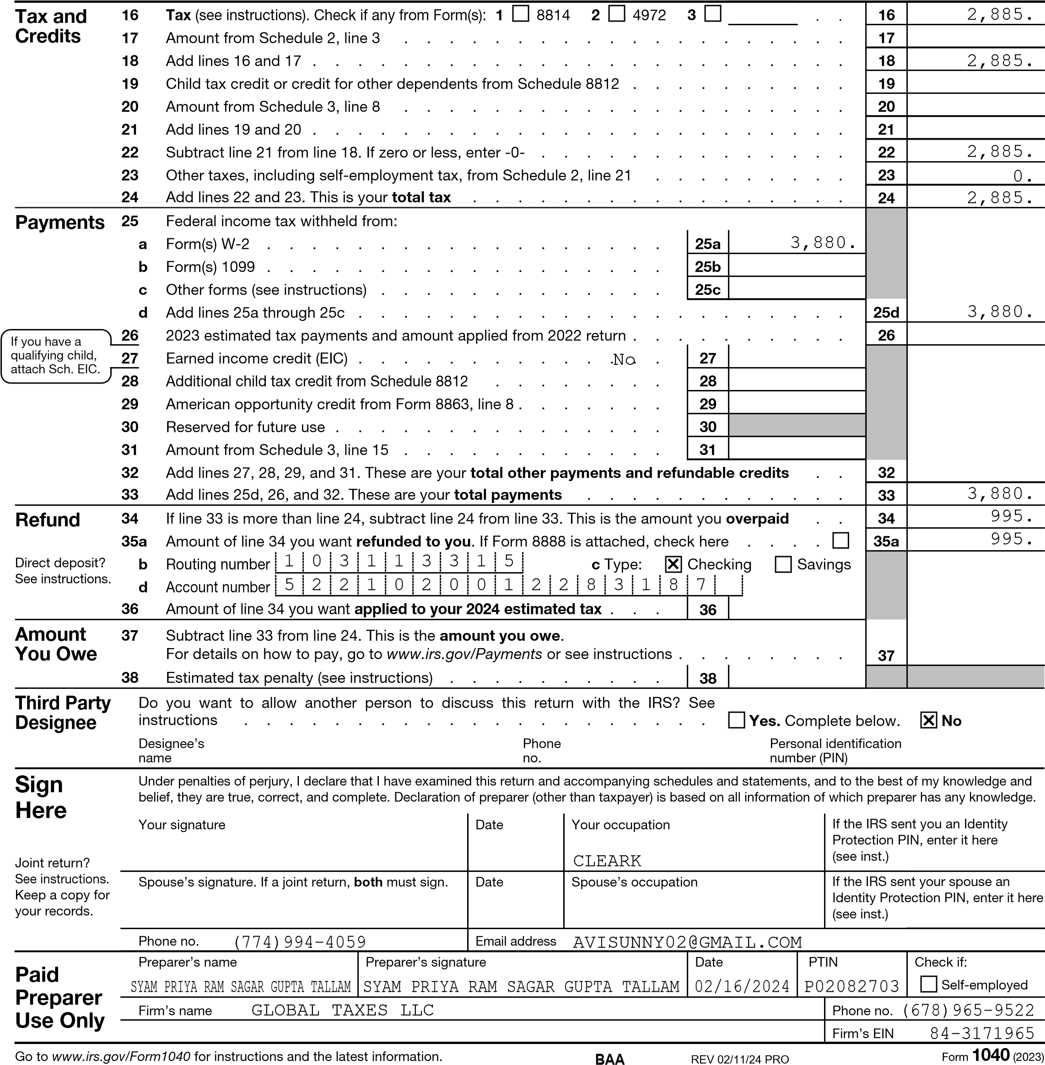Firm’s address 245 ROONEY CT E BRUNSWICK NJ 08816

SCHEDULE 1 Additional Income and Adjustments to Income OMB No. 1545-0074

(Form 1040) 20**23**

Attach to Form 1040, 1040-SR, or 1040-NR.

Department of the Treasury Go to *www.irs.gov/Form1040* for instructions and the latest information. Attachment 01

Internal Revenue Service Sequence No.

Name(s) shown on Form 1040, 1040-SR, or 1040-NR Your social security number

KOUSHIK JILLA 684-02-8706

# Part I Additional Income

1 Taxable refunds, credits, or offsets of state and local income taxes . . . . . . . . . 1

2a Alimony received . . . . . . . . . . . . . . . . . . . . . . . . . . . 2a b Date of original divorce or separation agreement (see instructions):

3 Business income or (loss). Attach Schedule C . . . . . . . . . . . . . . . . . 3 4 Other gains or (losses). Attach Form 4797 . . . . . . . . . . . . . . . . . . 4

1. Rental real estate, royalties, partnerships, S corporations, trusts, etc. Attach Schedule E . 5 -8,310.
2. Farm income or (loss). Attach Schedule F . . . . . . . . . . . . . . . . . . . 6
3. Unemployment compensation . . . . . . . . . . . . . . . . . . . . . . . 7
4. Other income:
5. Net operating loss . . . . . . . . . . . . . . . . . . . 8a ( )
6. Gambling . . . . . . . . . . . . . . . . . . . . . . 8b c Cancellation of debt . . . . . . . . . . . . . . . . . . 8c
7. Foreign earned income exclusion from Form 2555 . . . . . . . 8d ( )
8. Income from Form 8853 . . . . . . . . . . . . . . . . . 8e f Income from Form 8889 . . . . . . . . . . . . . . . . . 8f g Alaska Permanent Fund dividends . . . . . . . . . . . . . 8g h Jury duty pay . . . . . . . . . . . . . . . . . . . . . 8h i Prizes and awards . . . . . . . . . . . . . . . . . . . 8i j Activity not engaged in for profit income . . . . . . . . . . . 8j k Stock options . . . . . . . . . . . . . . . . . . . . . 8k l Income from the rental of personal property if you engaged in the rental for profit but were not in the business of renting such property . . . 8l
9. Olympic and Paralympic medals and USOC prize money (see

instructions) . . . . . . . . . . . . . . . . . . . . . 8m

1. Section 951(a) inclusion (see instructions) . . . . . . . . . . 8n o Section 951A(a) inclusion (see instructions) . . . . . . . . . . 8o p Section 461(l) excess business loss adjustment . . . . . . . . 8p q Taxable distributions from an ABLE account (see instructions) . . . 8q r Scholarship and fellowship grants not reported on Form W-2 . . . 8r

s Nontaxable amount of Medicaid waiver payments included on Form

1040, line 1a or 1d . . . . . . . . . . . . . . . . . . . 8s ( ) t Pension or annuity from a nonqualifed deferred compensation plan or

a nongovernmental section 457 plan . . . . . . . . . . . . 8t

u Wages earned while incarcerated . . . . . . . . . . . . . 8u z Other income. List type and amount:

8z

1. Total other income. Add lines 8a through 8z . . . . . . . . . . . . . . . . . . 9
2. Combine lines 1 through 7 and 9. This is your additional income. Enter here and on Form

1040, 1040-SR, or 1040-NR, line 8 . . . . . . . . . . . . . . . . . . . . . 10 -8,310.

For Paperwork Reduction Act Notice, see your tax return instructions. Schedule 1 (Form 1040) 2023

Schedule 1 (Form 1040) 2023 Page 2

|  |  |  |  |  |  |
| --- | --- | --- | --- | --- | --- |
| Part II | Adjustments to Income | | | | |
| 1. Educator expenses . . . . . . . . . . . . . . . . . . . . 2. Certain business expenses of reservists, performing artists, and fee-basis government officials. Attach Form 2106 . . . . . . . . . . . . . . . . . 13 Health savings account deduction. Attach Form 8889 . . . . . . . 3. Moving expenses for members of the Armed Forces. Attach Form 3903 4. Deductible part of self-employment tax. Attach Schedule SE . . . . 16 Self-employed SEP, SIMPLE, and qualified plans . . . . . . . . . 17 Self-employed health insurance deduction . . . . . . . . . . .   18 Penalty on early withdrawal of savings . . . . . . . . . . . . .  19a Alimony paid . . . . . . . . . . . . . . . . . . . . . . b Recipient’s SSN . . . . . . . . . . . . . . . . . . . . . c Date of original divorce or separation agreement (see instructions):   1. IRA deduction . . . . . . . . . . . . . . . . . . . . . . 2. Student loan interest deduction . . . . . . . . . . . . . . . 22 Reserved for future use . . . . . . . . . . . . . . . . . . 23 Archer MSA deduction . . . . . . . . . . . . . . . . . . 3. Other adjustments:    1. Jury duty pay (see instructions) . . . . . . . . . . . . . .    2. Deductible expenses related to income reported on line 8l from the rental of personal property engaged in for profit . . . . . . . .    3. Nontaxable amount of the value of Olympic and Paralympic medals and USOC prize money reported on line 8m . . . . . . . . . . d Reforestation amortization and expenses . . . . . . . . . . .   e Repayment of supplemental unemployment benefits under the Trade  Act of 1974 . . . . . . . . . . . . . . . . . . . . . . f Contributions to section 501(c)(18)(D) pension plans . . . . . . . g Contributions by certain chaplains to section 403(b) plans . . . . h Attorney fees and court costs for actions involving certain unlawful discrimination claims (see instructions) . . . . . . . . . . . .  i Attorney fees and court costs you paid in connection with an award from the IRS for information you provided that helped the IRS detect tax law violations . . . . . . . . . . . . . . . . . . . j Housing deduction from Form 2555 . . . . . . . . . . . . .  k Excess deductions of section 67(e) expenses from Schedule K-1 (Form  1041) . . . . . . . . . . . . . . . . . . . . . . . . z Other adjustments. List type and amount:   1. Total other adjustments. Add lines 24a through 24z . . . . . . . . 2. Add lines 11 through 23 and 25. These are your adjustments to income Form 1040, 1040-SR, or 1040-NR, line 10 . . . . . . . . . . . | | . .  . .  . .  . .  . .  . .  . . . . . .  .  . . . .  . .  . .  24a | . . . . .  . . . . .  . . . . .  . . . . .  . . . . .  . . . . .  . . . . . . . . . .  . . . . .  . . . . . . . . . .  . . . . .  . . . . . | 11 |  |
| 12 |  |
| 13 |  |
| 14 |  |
| 15 |  |
| 16 |  |
| 17 |  |
| 18 |  |
| 19a |  |
|  |  |
| 20 |
| 21 |  |
| 22 |  |
| 23 |  |
|  |  |
| 24b |  |
| 24c |  |
| 24d |  |
| 24e |  |
| 24f |  |
| 24g |  |
| 24h |  |
| 24i |  |
| 24j |  |
| 24k |  |
| 24z |  |
| . . . . . . .  . Enter here and on  . . . . . . . | | 25 |
| 26 |  |

**BAA** REV 02/11/24 PRO Schedule 1 (Form 1040) 2023

|  |  |  |  |  |
| --- | --- | --- | --- | --- |
| SCHEDULE E  (Form 1040)  Department of the Treasury  Internal Revenue Service | | Supplemental Income and Loss  (From rental real estate, royalties, partnerships, S corporations, estates, trusts, REMICs, etc.)  Attach to Form 1040, 1040-SR, 1040-NR, or 1041.  Go to *www.irs.gov/ScheduleE* for instructions and the latest information. | | OMB No. 1545-0074 |
| 20**23**  Attachment Sequence No. 13 |
| Name(s) shown on return | | | Your social security number | |
| KOUSHIK JILLA | | | 684-02-8706 | |
| Part I | Income or Loss From Rental Real Estate and Royalties | | | |

Note: If you are in the business of renting personal property, use Schedule C. See instructions. If you are an individual, report farm rental income or loss from Form 4835 on page 2, line 40.

1. Did you make any payments in 2023 that would require you to file Form(s) 1099? See instructions . . . . . Yes No
2. If “Yes,” did you or will you file required Form(s) 1099? . . . . . . . . . . . . . . . . . . Yes No

1a Physical address of each property (street, city, state, ZIP code)

|  |  |  |  |  |  |  |  |  |  |  |  |  |
| --- | --- | --- | --- | --- | --- | --- | --- | --- | --- | --- | --- | --- |
| A | 5-23-743/2 NAIMNAGAR WARANGAL TELANGANA IN 5060 | | | | 02 |  | |  | |  | | |
| B |  | | | |  |  | |  | |  | | |
| C |  | | | |  |  | |  | |  | | |
| 1b | Type of Property (from list below) | 2 For each rental real estate property listed above, report the number of fair rental and personal use days. Check the QJV box only if you meet the requirements to file as a qualified joint venture. See instructions. | | |  | Fair Rental  Days | | Personal Use Days | | QJV | | |
| A | 3 | A | 365 | | 0 | |  |  |  |
| B |  | B |  | |  | |  |  |  |
| C |  | C |  | |  | |  |  |  |
| Type of Property: | | |  |  | | |  | |
| 1. Single Family Residence 2. Multi-Family Residence | | | 1. Vacation/Short-Term Rental 2. Commercial | 1. Land 2. Royalties | | | 1. Self-Rental 2. Other (describe) | |

|  |  |  |  |  |  |  |
| --- | --- | --- | --- | --- | --- | --- |
| Income: | | Properties: | | | | |
| A | | B | | C |
| 3 Rents received . . . . . . . . . . . . . . 4 Royalties received . . . . . . . . . . . . . | 3 | 480. | |  | |  |
| 4 |  | |  | |  |
| Expenses:   1. Advertising . . . . . . . . . . . . . . . 2. Auto and travel (see instructions) . . . . . . . 3. Cleaning and maintenance . . . . . . . . . . 4. Commissions . . . . . . . . . . . . . . 9 Insurance . . . . . . . . . . . . . . . . 5. Legal and other professional fees . . . . . . . 6. Management fees . . . . . . . . . . . . . 7. Mortgage interest paid to banks, etc. (see instructions) 8. Other interest . . . . . . . . . . . . . . 14 Repairs . . . . . . . . . . . . . . . . . 9. Supplies . . . . . . . . . . . . . . . . 10. Taxes . . . . . . . . . . . . . . . . . 11. Utilities . . . . . . . . . . . . . . . . . 12. Depreciation expense or depletion . . . . . . . 19 Other (list) 13. Total expenses. Add lines 5 through 19 . . . . . 14. Subtract line 20 from line 3 (rents) and/or 4 (royalties). If result is a (loss), see instructions to find out if you must file Form 6198 . . . . . . . . . . . . . . 15. Deductible rental real estate loss after limitation, if any, on Form 8582 (see instructions) . . . . . . . .   23a Total of all amounts reported on line 3 for all rental properties b Total of all amounts reported on line 4 for all royalty properties c Total of all amounts reported on line 12 for all properties d Total of all amounts reported on line 18 for all properties e Total of all amounts reported on line 20 for all properties   1. Income. Add positive amounts shown on line 21. Do not 2. Losses. Add royalty losses from line 21 and rental real estate losses from line 22. Enter total losses here 3. Total rental real estate and royalty income or (loss).   here. If Parts II, III, and IV, and line 40 on page 2 do not apply to you, also enter this amount on  Schedule 1 (Form 1040), line 5. Otherwise, include this amount in the total on line 41 on page 2 | 5 |  | |  | |  |
| 6 |  | |  | |  |
| 7 | 830. | |  | |  |
| 8 |  | |  | |  |
| 9 |  | |  | |  |
| 10 |  | |  | |  |
| 11 | 1,540. | |  | |  |
| 12 |  | |  | |  |
| 13 |  | |  | |  |
| 14 | 1,970. | |  | |  |
| 15 | 2,150. | |  | |  |
| 16 |  | |  | |  |
| 17 | 2,300. | |  | |  |
| 18 |  | |  | |  |
| 19 |  | |  | |  |
| 20 | 8,790. | |  | |  |
| 21 | -8,310. | |  | |  |
| 22 | ( )8,310. | | ( ) | | ( ) |
| . . . .  . . . . . . . . . .  . . . . . .  . . . . . .  include any losses  Combine lines 24 and 25. Enter the result | | 23a | 480. | |  |
| 23b |  | |
| 23c |  | |
| 23d |  | |
| 23e | 8,790. | |
| . . . . . . .  . | | 24 |  |
| 25 | ( 8,310. ) |
| 26 |  |
| -8,310. |

For Paperwork Reduction Act Notice, see the separate instructions. Schedule E (Form 1040) 2023

**BAA** REV 02/11/24 PRO

**2023 TC-40**

INTUIT

|  |
| --- |
| **Utah State Tax Commission**  **Utah Individual Income Tax Return**  **All state income tax dollars support education, children and individuals with disabilities.** |

• Amended Return - enter code: (see instructions)

**40301**

1555

Full-yr Resident?

Your Social Security No. Your first name Your last name Y/N

## 684028706 KOUSHIK JILLA Y

Spouse’s Soc. Sec. No. Spouse’s first name Spouse's last name

Address Telephone number

## If deceased, complete 524 CLIFFVIEW DRIVE 774-994-4059

City State ZIP+4 Foreign country (if not U.S.)

page 3, Part 1

## MOAB UT 84532

|  |  |  |  |  |
| --- | --- | --- | --- | --- |
| **1 Filing Status - enter code** | | • **2** | **Qualifying Dependents** | **3 Election Campaign Fund** |
|  | **1** = Single | **a** | Dependents age 16 and under | Does not increase your tax or reduce your refund. |
| • 1        If using cod | 1. = Married filing jointly 2. = Married filing separately 3. = Head of household 4. = Qualifying surviving spouse   e 2 or 3, enter spouse’s name and SSN above | **b** **c** **d**    **Se** | Other dependents Dependents born in 2023  0 Total (add lines a, b and c)    **e instructions.** | Enter the code for the Yourself Spouse party of your choice. • •  See instructions for code letters or go to **incometax.utah.gov/elect**.  If no contribution, enter **N**. |

1. Federal adjusted gross income from federal return • 4 39703
2. Additions to income from TC-40A, Part 1 (attach TC-40A, page 1) • 5
3. Total income - add line 4 and line 5 6 39703
4. State tax refund included on federal form **1040, Schedule 1, line 1** (if any) • 7
5. Subtractions from income from TC-40A, Part 2 (attach TC-40A, page 1) • 8
6. **Utah taxable income/loss** - subtract the sum of lines 7 and 8 from line 6 • 9 39703
7. **Utah tax** - multiply line 9 by 4.65% (.0465) (not less than zero) • 10 1846
8. Utah personal exemption (multiply line 2d by $1,941) • 11 0

|  |
| --- |
| **Electronic filing is quick, easy and free, and will**  **speed up your refund.** |
| **To learn more, go to**  **tap.utah.gov** |

1. Federal standard or itemized deductions • 12 13850
2. Add line 11 and line 12 13 13850
3. State income tax included in federal itemized deductions • 14
4. Subtract line 14 from line 13 15 13850

1. Initial credit before phase-out - multiply line 15 by 6% (.06) • 16 831

|  |  |  |  |  |
| --- | --- | --- | --- | --- |
| 17 Enter: **$16,742** (single or married filing separately); **$25,114** (head of • 17 household); or **$33,484** (married filing jointly or qualifying surviving spouse) 18 Income subject to phase-out - subtract line 17 from line 9 (not less than zero) 18   1. Phase-out amount - multiply line 18 by 1.3% (.013) • 19 2. Taxpayer tax credit - subtract line 19 from line 16 (not less than zero) 3. If you are a qualified exempt taxpayer, enter “X” (complete worksheet in instr.) • 21 |  | 16742  22961  298 | • 20 | 533 |

22 **Utah income tax** - subtract line 20 from line 10 (not less than zero) • 22 1313

REV 11/30/23 PRO

**Utah Individual Income Tax Return (continued)** INTUIT **TC-40** Pg. 2

## **40302** SSN 684028706 Last name JILLA **2023**

USTC ORIGINAL FORM

|  |  |  |  |  |  |  |  |
| --- | --- | --- | --- | --- | --- | --- | --- |
| 1. Enter tax from TC-40, page 1, line 22 2. Apportionable nonrefundable credits from TC-40A, Part 3 (attach TC-40A, page 1) 3. Full-year resident, subtract line 24 from line 23 (not less than zero)   Non or Part-year resident, complete and enter the UTAH TAX from TC-40B, line 41   1. Nonapportionable nonrefundable credits from TC-40A, Part 4 (attach TC-40A, page 1) 2. Subtract line 26 from line 25 (not less than zero) 3. Voluntary contributions from TC-40, page 3, Part 4 (attach TC-40, page 3) 4. AMENDED RETURN ONLY - previous refund      1. Recapture of low-income housing credit 2. Utah use tax 3. **Total tax, use tax and additions to tax** (add lines 27 through 31) |  |  |  |  | 23   * 24 * 25 * 26   27   * 28 * 29 * 30 * 31   32   * 33 * 34 * 35 * 36 * 37   38   * 39   40   * 41 * 42 * 43   checking | savings  • | 1313  1313  1313  1313  2280  2280  967  foreign  • |
| 33 Total withholding - If you have mineral production withholding or pass-through entity withholding, | | |
| complete page 3, Part 5. If not, enter on line 33 the total of TC-40W, Part 1.   1. Credit for Utah income taxes prepaid from TC-546 and 2022 refund applied to 2023 2. AMENDED RETURN ONLY - previous payments 3. Nonapportionable refundable credits from TC-40A, Part 5 (attach TC-40A, page 2) 4. Apportionable refundable credits from TC-40A, Part 6, line c (attach TC-40A, page 2) 5. Total withholding and refundable credits - add lines 33 through 37 6. **TAX DUE** - subtract line 38 from line 32 (not less than zero) 7. Penalty and interest (see instructions) 8. **TOTAL DUE - PAY THIS AMOUNT** - add line 39 and line 40      1. **REFUND** - subtract line 32 from line 38 (not less than zero) 2. Voluntary subtractions from refund (not greater than line 42)   Enter the total from page 3, Part 6 |  |  |
| 44 **REMAINING REFUND DIRECT DEPOSIT** - your account information (see instructions for foreign accounts) | | | | |
| • Routing number 103113315 • Account number 5221020012283187 Type: • X | | | | | |

Under penalties of perjury, I declare to the best of my knowledge and belief, this return and accompanying schedules are true, correct and complete.

|  |  |  |  |  |  |
| --- | --- | --- | --- | --- | --- |
| SIGN Your signature Date  HERE | | Spouse’s signature (if filing jointly) | |  | Date |
| Third Party | Name of designee (if any) you authorize to discuss this return | | Designee’s telephone number | Designee PIN |  |
| Designee |  | |  | •  Preparer’s PTIN |  |
|  | Preparer’s signature Date | | Preparer’s telephone number |
| Paid  Preparer’s  Section | SYAM PRIYA RAM SAGAR G02/16/24 | | 6789659522 | •  Preparer’s EIN  • | P02082703  843171965 |
| Firm’s name GLOBAL TAXES LLC and address 245 ROONEY CT  E BRUNSWICK NJ 08816 | | |

Attach page 3 if you: are filing for a deceased taxpayer, are filing a fiscal year return, filed IRS form 8886, are making contributions, want to deposit into a my529 account, want to apply all/part of your refund to next year’s taxes, have mineral production or pass-through entity withholding, or no longer qualify for a homeowner’s exemption.

REV 11/30/23 PRO

|  |  |  |  |  |
| --- | --- | --- | --- | --- |
| **40309** | **Part 1 - Utah Withholding Tax Schedule**  SSN 684-02-8706 Last name JILLA | INTUIT | **TC-40W 2023** | Pg. 1 |

USTC ORIGINAL FORM

|  |  |  |  |
| --- | --- | --- | --- |
| **Line Explanations** | | **IMPORTANT** | |
| 1 Employer/payer ID number from W-2 box “b” or 1099 | | **Do not send your W-2s or 1099s with your return.** Instead enter | |
| 2 Utah withholding ID number from W-2 box “15” or 1099 | | W-2 or 1099 information below, but **only** if there is Utah withholding | |
| **(14 characters, ending in WTH, no hyphens)** | | on the form. | |
| 1. Employer/payer name and address from W-2 box “c” or 1099 2. Enter “X” if reporting Utah withholding from form 1099 | | Use additional forms TC-40W if you have more than four W-2s and/or | |
| 5 Employee’s Social Security number from W-2 box “a” or 1099 | | 1099s with Utah withholding tax. | |
| 1. Utah wages or income from W-2 box “16” or 1099 2. Utah withholding tax from W-2 box “ | 17” or 1099 | Enter mineral production withholding from TC-675R in Part 2 of TC-40W; enter pass-through entity withholding in Part 3 of TC-40W. | |
| **First W-2 or 1099** |  | **Second W-2 or 1099** |  |
| 1. 205637217 2. 12469016004 WTH (14 characters, no hyphens) 3. MAA KRUPA HOSPITALITY, LLC   426 N MAIN  MOAB UT84532  4   1. 684028706 2. 48013 3. 2280 | | 1  2  3  4  5  6  7 | (14 characters, no hyphens) |
| **Third W-2 or 1099**  1  2 (14 characters, no hyphens)  3  4  5  6  7 | | **Fourth W-2 or 1099**  1  2  3  4  5  6  7 | (14 characters, no hyphens) |

### Total Utah withholding tax from all lines 7: 2280

If you have nothing to enter on TC-40W, page 2, enter this total on TC-40, page 2, line 33.

If you have entries on TC-40W, page 2, enter this total on TC-40, page 3, Part 5, line 1.

**Submit page ONLY if data entered.**

**Attach completed schedule to your Utah Income Tax Return.**

**Do not attach W-2s or 1099s to your Utah return.**

REV 11/30/23 PRO