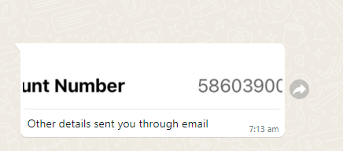

586039005273

Hi Hema,

As discussed, file with Single and before planning. Please find the details below.

Bank Details:

Bank Name : BANK OF AMERICA

Routing Number: 111000025

Account Number: Will Message you

Account Type: Checking

Account Holder: Nagaraju Kamisetty

Attached License.

Indian Address:

  Nagaraju Kamisetty,

|  |
| --- |
| FF6, Mythri Residency, Plot No.290 and 291  Street No.7, Road – 2, P and T Colony, Kakatiya Hospitals Road, Medipally, Ghatkesar, K.V.Rangareddy, Telangana, India - 500098  Regards,  Nag |