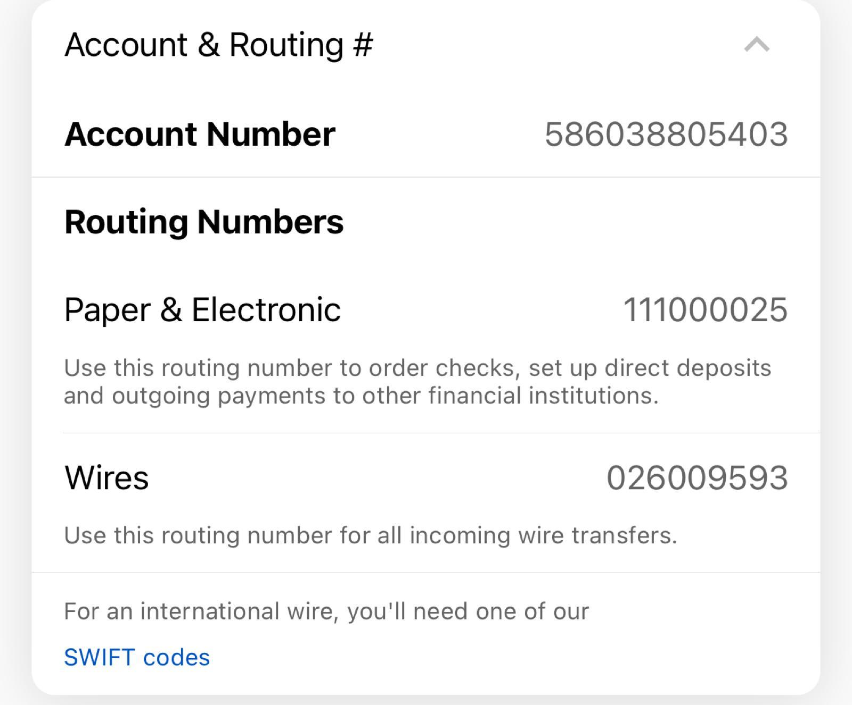

Bank Name: Bank of America

Checking account

Account Holder India address: G 002 Nishita Orchid, 17th D cross, 13th Main,JP Nagar 5th phase, Bangalore 560078