**CLIENT TAX NOTES – TY2023**

Dear Tax Payer,

Greetings!

Please fill the below Tax Organizer form and upload it in your secured login or even you can E-mail it to us at [INFO@gtaxfile.com](mailto:INFO@gtaxfile.com) along with your Form W2 & any other income statement and any other relevant documents to prepare and analyze your taxes and share you a Free Tax return Draft Copy for TY2023.

**PERSONALINFORMATION**

|  |  |  |  |  |  |
| --- | --- | --- | --- | --- | --- |
| **Particulars** | **Primary Taxpayer** | **Spouse** | **Dependent 1 (Child-1)** | **Dependent 2**  **(Child-2)** | **Dependent 3**  **(Other dependent person)** |
| **FIRST NAME (PER SSN/ITIN)** | **Venkatesh** | **Juhi** |  |  |  |
| **MIDDLE NAME (PER SSN/ITIN)** |  |  |  |  |  |
| **LAST NAME (PER SSN/ITIN)** | **Vadakkapattu** | **Baxi** |  |  |  |
| **SSN/ITIN NUMBER** | **765325460** | **638086928** |  |  |  |
| **DATE OF BIRTH (MM/DD/YY)** | **03/20/1982** | **07/14/1984** |  |  |  |
| **RELATIONSHIP WITH PRIMARY TAXPAYER** | **Self** | **Wife** |  |  |  |
| **OCCUPATION** | **Engineer** | **engineer** |  |  |  |
| **CURRENT ADDRESS** | **7819 Trinity rose Ct,**  **Richmond, TX**  **77407** | **Same** |  |  |  |
| **CELL NUMBER** | **832-480-0987** | **832-908-6450** |  |  |  |
| **ALTERNATIVE NUMBER (HOME)** | **-** | **-** |  |  |  |
| **WORK NUMBER (WITH EXTENSION)** | **-** | **-** |  |  |  |
| **EMAIL ADDRESS** | **Venkatesh.vc@gmail.com** |  |  |  |  |
| **FIRST PORT OF ENTRY DATE (MM/DD/YY)** | **2003** | **2006** |  |  |  |
| **VISA STATUS ON 31ST DEC 2023** | **TN Visa** | **TN Visa** |  |  |  |
| **ANY CHANGE IN VISA STATUS DURING THE YEAR 2023 (IF YES PLS. SPECIFY)** | **no** | **No** |  |  |  |
| **MARITAL STATUS AS ON**  **DEC 31,2022** | **Married** | **married** |  |  |  |
| **DATE OF MARRIAGE (IF APPLICABLE)** | **Dec 2010** | **same** |  |  |  |
| **FILING STATUS (SINGLE/MARRIED/HEAD OF HOUSEHOLD)** | **Married jointly** |  |  |  |  |
| **NO. OF MONTHS STAYED IN US DURING 2023** | **9** | **11** |  |  |  |
| **WILL YOU STAY IN US FOR MORE THAN 183 DAYS IN YEAR 2024 – (YES OR NO)** | **Yes** | **yes** |  |  |  |
| **IF ANY OTHER INFORMATION** | **-** | **-** |  |  |  |

**NOTE: IF YOU DO NOT HAVE AN SSN FOR YOUR SPOUSE/DEPENDENTS WE CAN APPLY FOR ITIN. FOR ITIN APPLICATION PROCESSING PLEASE REACH US ON (470)-480-1883 OR WRITE TO info@gtaxfile.com**

**CHILD AND DEPENDENT CARE EXPENSES PROVIDER DETAILS -**

|  |  |  |  |  |
| --- | --- | --- | --- | --- |
| **DEPENDENT NAME** | **NAME OF THE ORGANIZATION** | **ADDRESS WITH PHONE NUMBER** | **FEDERAL ID NUMBER (EIN / SSN) OF THE ORGANIZATION / PERSON WHO PROVIDED THE CARE.** | **AMOUNT PAID** |
| **No children** |  |  |  |  |
|  |  |  |  |  |
|  |  |  |  |  |

**1. DEPENDENTS UNDER AGE 24 WITH UNEARNED INCOME (E.G. INTEREST OR DIVIDENDS EARNED, STOCK SALE PROCEEDS) GREATER THAN $950 MAY NEED TO FILE A RETURN.**

**NOTE: DEPENDENTS WITH UNEARNED INCOME GREATER THAN $1,900 ARE SUBJECT TO THEIR PARENT’S TAX RATE. COORDINATION OF RETURNS BETWEEN PARENT AND CHILD IS VERY IMPORTANT.**

**2. PLEASE COMPLETE CHILDCARE EXPENSES SECTION ONLY IF BOTH TAXPAYER & SPOUSE ARE WORKING.**

**BANK ACCOUNT DETAILS**

|  |  |
| --- | --- |
| **BANK DETAILS FOR DIRECT DEPOSIT OF REFUND AMOUNT/AUTO WITHDRAWAL OF OWE AMOUNT(OPTIONAL)** | |
| BANK NAME | Chase |
| BANK ROUTING NUMBER  (PAPER OR ELECTRONIC) |  |
| BANK ACCOUNT NUMBER |  |
| CHECKING / SAVING ACCOUNT |  |
| ACCOUNT HOLDER NAME |  |

**RESIDENCY DETAILS:**

|  |  |  |  |  |  |  |  |
| --- | --- | --- | --- | --- | --- | --- | --- |
| **STATES RESIDENCY DETAILS** | | | | **STATES RESIDENCY DETAILS** | | | |
| **TAXPAYER** | | | | **SPOUSE** | | | |
| **YEAR** | **STATE(S)** | **FROM**  **(MM/DD/YY)** | **TO**  **(MM/DD/YY)** | **YEAR** | **STATE(S)** | **FROM**  **(MM/DD/YY)** | **TO**  **(MM/DD/YY)** |
| **2023** | TX | 01/2023 | 12/2023 | **2023** | TX | 01/2023 | 12/2023 |
| **2022** |  |  |  | **2022** |  |  |  |
| **2021** |  |  |  | **2021** |  |  |  |

**Medical Expenses:**

|  |  |  |  |  |  |
| --- | --- | --- | --- | --- | --- |
| **Prescription medications** | **Health insurance premiums** | **Doctors, Dentists, etc.** | **Hospitals, clinics, etc.** | **Eyeglasses and contact lenses** | **Maternity expenses, if any** |
|  | 2300 |  |  |  |  |
|  | 2314 |  |  |  |  |
|  |  |  |  |  |  |
|  |  |  |  |  |  |

**Taxes Paid:**

|  |  |  |  |
| --- | --- | --- | --- |
| **Real estate taxes** | **State and local Personal property taxes** | **Other taxes, If any** | **Additional State taxes paid while filing last year taxes (TY2022).** |
| 12,297 |  |  |  |
|  |  |  |  |

**Home Mortgage Interest**

|  |  |  |  |  |
| --- | --- | --- | --- | --- |
| **Home mortgage interest paid in US -*FORM 1098Mandatory** | **Points, if any** | **Home mortgage interest paid in INDIA – *Below details required** | **Mortgage insurance premiums paid, if any** | **Investment interest. Attach Form 4952** |
| 11,825 |  |  |  |  |
|  |  |  |  |  |
|  |  | **Bank Name (Foreign)** | **Bank Address (Foreign)** |  |
|  |  |  |  |  |

**Note**: Are you planning to purchase any House Property in Tax Year 2024 In United States Of America

Please Mention Yes Or No Yes No

|  |  |  |  |  |  |
| --- | --- | --- | --- | --- | --- |
| **CHARITY CONTRIBUTIONS** | | | | | |
| **S. No** | **Charitable Institution Name** | **Donated Amount** | **Property Donated** | **FMV of Property Donated** | **No. of trips driven and one way distance** |
| 1 | Ashtalakshmi temple | 1008 |  |  |  |
| 2 | Chinmaya Mission | 501 |  |  |  |
| 3 | ­­Isha | 68 |  |  |  |
| 4 | Sharadamba temple | 380 |  |  |  |
| 5 | Texas Gaushala | 30 |  |  |  |
| 6 | Swaminarayan | 51 |  |  |  |
| 7 | LuvMichael & Gofundme | 50 |  |  |  |
| 8 | Miscl. | 50 |  |  |  |
|  |  |  |  |  |  |
| **Note**: **1) Cash Contribution more than $ 250 receipts are Mandatory**  **2) Non - Cash Contribution more than $ 500 receipts are Mandatory** | | | | | |
|  | | | | | |

|  |  |  |  |  |  |  |
| --- | --- | --- | --- | --- | --- | --- |
| **Vehicle Information** | | | | | | |
|  | **Name of the Vehicle** | **Make & Model** | **Total miles driven in year 2022** | **One-way distance from Home to Office** | **Parking and toll** | **Purchase date** |
| Taxpayer | Sonata | Sonata GLS | 4000 |  |  | 2016 |
| Taxpayer | Lexus | Lexus NX | 8000 | 10 miles | $5 per day | 2019 |
| Spouse |  |  |  |  |  |  |

**Business Assets Or Environment Saving Assets purchased:**

|  |  |  |  |
| --- | --- | --- | --- |
| **Name of the Asset Purchased in 2022** | **Cost** | **Purchase date** | **Receipt Available or not** |
|  |  |  |  |
|  |  |  |  |
|  |  |  |  |
|  |  |  |  |

**HEALTH INSURANCE:**

|  |  |
| --- | --- |
| **Are you and your dependents covered under Health Coverage as per Federal laws??? Mandatory** |  |
| **Yes employment health insurance & HSA coverage** |  |
| **If not so, please specify who are not covered and for how many months** |  |
| **IF you/your spouse resident of MA state, Covered by Massachusetts Health Insurance. Please provide From 1099-HC.** |  |

**INVESTMENTS – SALE &PURCHASE OF STOCKS**

|  |  |  |  |  |  |  |  |  |  |
| --- | --- | --- | --- | --- | --- | --- | --- | --- | --- |
| Purchase Date | Description of Stock | Qty | Rate per Unit | Total =Qty*Rate | Sale Date | Description of the Stock | Qty | Rate per Unit | Total=  Qty*Rate |
|  |  |  |  |  |  |  |  |  |  |
|  |  |  |  |  |  |  |  |  |  |

Note: If you have more than 10 transactions, Please send us the sale and purchase details in an Excel sheet with the columns listed above.

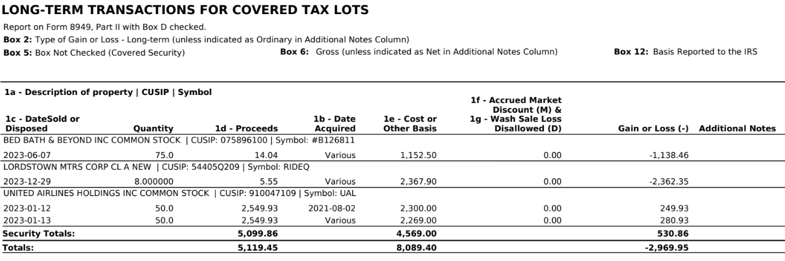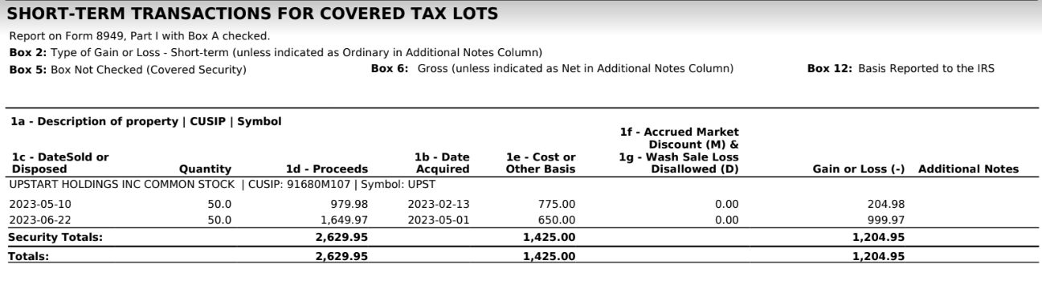

**Foreign Income and Expenses (IF Any)**

|  |  |  |  |  |
| --- | --- | --- | --- | --- |
| **Particulars** | **Salary income** | **Rental Income** | **Interest Income** | **Others (If any)** |
| 1. **Amount of Foreign Income** |  |  |  |  |
| 1. **Foreign Taxes Withheld (like Form-16/16A)** |  |  |  |  |

|  |  |  |
| --- | --- | --- |
| **Other Deductions – Adjustments to Income** | | |
| **Particulars** | **Taxpayer** | **Spouse** |
| **Educator expenses – only for Teaching profession ($ 250)** |  |  |
| **Health savings account Contribution** | $3291  $2314 | $2400 |
| **Penalty on early withdrawal of saving** |  |  |
| **Contribution towards Traditional IRA for 2022** |  |  |
| **Student loan interest deduction – Provide Form 1098 E** |  |  |
| **Tuition & Fees Provide Form 1098-T** |  |  |
| **Gambling Losses** |  |  |
|  |  |  |
| **Certified pre-owned Plug-in electric vehicle, purchase price $39,000 (does it qualify for $4000 eve credit?)** |  |  |
| **Maintenance expenses sent to Mother in India** | $8000 |  |
| Venky joined another company from mid June 2023; it is a work from home setup.  Internet is $76.59 per month. The office room is 500 sq ft in our house which is 3500 sq ft.  The mortgage and property tax have been provided. The electricity is average of $300 per month. |  |  |

**FOR FBAR/FATCA**

|  |  |  |
| --- | --- | --- |
|  | **Tax Payer(No)** | **Spouse (No)** |
| **Did you have more than $10,000 in your Foreign Accounts at any time during the Tax Year 2022** |  |  |
| **Did you have more than $50,000 in your Foreign Accounts at any time during the**  **Tax Year 2022** |  |  |

Note: You may have to FBAR (Foreign Bank Account Report) before April 18, 2023 if the aggregate of your Bank Accounts/Securities Accounts/Other Financial Accounts exceeded $10,000 at any time during the tax year 2022.You may have to file FATCA (Foreign Account tax Compliance Act) before April 18, 2023 with your tax return if the aggregate of your Bank Accounts/Securities/Other financial Accounts exceeded $50,000 at any time during the tax year 2022.

**UPLOAD /EMAIL THE FOLLOWING DOCUMENTS ALONG WITH THE THIS TAX ORGANISER**

|  |  |
| --- | --- |
| Duly Filled TY-2022 Tax Organizer |  |
| **W-2’s**:Wages/salaries from All employers – Upload Documents |  |
| **1099-INT &1099-DIV**: Interest & Dividends for All Accounts |  |
| **1099-B**: Sales of Securities, Mutual Funds, etc. |  |
| **Year-End**: Investment statements, Mutual Fund supplemental information |  |
| **1099-R**: Income from Pension, IRAs and Annuities |  |
| **1099-G**: Unemployment Compensation/state income tax refund |  |
| **K-1**:Partnerships,Trusts,Estates and S-Corporations |  |
| **Last Paystubs** of the year from ALL Employers |  |
| **1099-SSA/ 1099-RRB**: Social Security and Railroad Retirement benefits |  |
| **Scholarships, Fellowships and Grants Form 1042 S** |  |
| **Foreign Tax certificate ( if you made any income from foreign country during 2022)** |  |
| **Disability and Sick Pay** |  |
| **Gambling Winnings**  **Form W-2G – Income from Gambling** |  |
| **Prizes and Awards** |  |
| **Rental Income (if any) INDIA or USA** |  |
| **Alimony Received (if any)** |  |
| **Home Mortgage Statement (India) (From 01st Jan To 31st Dec)** |  |
| **Education Loan Interest Certificate (India) (From 01st Jan To 31st Dec)** |  |
| **Form-1099HC-(Details Required From Tax Payer who is residing in MA)** |  |
| **For New ITIN Or Renewal ITIN (Passport and VISA First and Last page is required)** |  |

|  |  |  |  |
| --- | --- | --- | --- |
| **Refer a friend(s) to get Referral Bonus@ $ 10 for Each paid client to us.\*\*** | | | |
| **S. No** | **Friend(s) Name** | **Friends E-mail ID** | **Contact Number** |
| **1** |  |  |  |
| **2** |  |  |  |
| **3** |  |  |  |
| **4** |  |  |  |
| **5** |  |  |  |
| **6** |  |  |  |