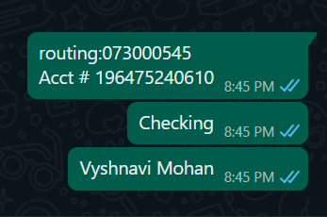

Driving License/ State issued photo ID Taxpayer Spouse

Number : M500-8609-7714-07

Issued State : Wisconsin

Issued Date : 4/09/2022

Expiration date : 06/14/2024

Type of ID (Driving License / State issued ID) :: Driving License

INDIAN HOME ADDRESS: AGK BHAVAN PUNNAMOODU, VARKALA,695141