Hi Sowmya,

Regarding the double taxation that I discussed with CPA - here is the proof.

My Etrade screenshot ( should be covered in Etrade documents that I shared earlier ).

Here for the RSUs - US taxes as well as Indian taxes are deducted.

Total earned is $13,814, out of that Indian taxes are 5,336.18 and you can see US taxes.  So in both countries it is taxed.

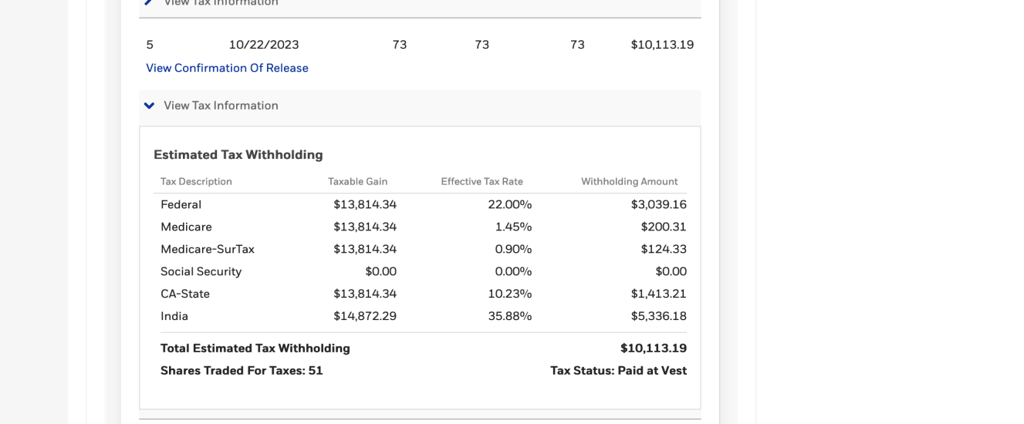

Here I am also attaching

India tax statement  files - 814876_TaxStatement_Jan2024.pdf and 814876_Payslip_Nov2023 (1).pdf (reflecting in November payslip)

US tax deducted statement  files- US-RSU-Tax-deducted-statement.pdf

In ETrade-tradesdownload(1).xls file  ( sold stocks to cover the taxes)

|  |  |  |  |  |  |  |  |  |
| --- | --- | --- | --- | --- | --- | --- | --- | --- |
| **10/23/2023** | Sell | CRM | 79466L302 | SALESFORCE INC UNSOLICITED TRADE | 51 | 200.97493 | 5.04 | 10244.68 |

So around 5k is deducted in the US which is supposed to be refunded.

Note: CPA asked me to share my efile tax website credentials - i don't find my deducted tax details in <https://www.incometax.gov.in>