Form

8879

(

Rev. January

2021)

Department of the Treasury

Internal Revenue Service

IRS

e-file

Signature Authorization

ERO must obtain and retain completed Form 8879.

Go to

www.irs.gov/Form8879

for the latest information.

OMB No. 1545-0074

Submission Identification Number (SID)

|  |  |  |  |
| --- | --- | --- | --- |
| Taxpayer’s name | |  | Social security number |
| KAMALAKANNAN GUNASEKARAN | |  | 676-53-4104 |
| Spouse’s name | |  | Spouse’s social security number |
| Part I | Tax Return Information — Tax Year Ending December 31, | 2023 (Enter year you are authorizing.) | |

Enter whole dollars only on lines 1 through 5.

Note: Form 1040-SS filers use line 4 only. Leave lines 1, 2, 3, and 5 blank.

|  |  |  |  |
| --- | --- | --- | --- |
| 1 Adjusted gross income . . . . . . . . . . . . . . . . . . . . . . . . . . 2 Total tax . . . . . . . . . . . . . . . . . . . . . . . . . . . . . . . 3 Federal income tax withheld from Form(s) W-2 and Form(s) 1099 . . . . . . . . . . . . . 4 Amount you want refunded to you . . . . . . . . . . . . . . . . . . . . . . 5 Amount you owe . . . . . . . . . . . . . . . . . . . . . . . . . . . . | | 1 | 26,000. |
| 2 | 1,241. |
| 3 | 2,270. |
| 4 | 1,029. |
| 5 |  |
| Part II | Taxpayer Declaration and Signature Authorization (Be sure you get and keep a copy of your return) | | |

Under penalties of perjury, I declare that I have examined a copy of the income tax return (original or amended) I am now authorizing, and to the best of my knowledge and belief, it is true, correct, and complete. I further declare that the amounts in Part I above are the amounts from the income tax return (original or amended) I am now authorizing. I consent to allow my intermediate service provider, transmitter, or electronic return originator (ERO) to send my return to the IRS and to receive from the IRS (a) an acknowledgement of receipt or reason for rejection of the transmission, (b) the reason for any delay in processing the return or refund, and (c) the date of any refund. If applicable, I authorize the U.S. Treasury and its designated Financial Agent to initiate an ACH electronic funds withdrawal (direct debit) entry to the financial institution account indicated in the tax preparation software for payment of my federal taxes owed on this return and/or a payment of estimated tax, and the financial institution to debit the entry to this account. This authorization is to remain in full force and effect until I notify the U.S. Treasury Financial Agent to terminate the authorization. To revoke (cancel) a payment, I must contact the U.S. Treasury Financial Agent at 1-888-353-4537. Payment cancellation requests must be received no later than 2 business days prior to the payment (settlement) date. I also authorize the financial institutions involved in the processing of the electronic payment of taxes to receive confidential information necessary to answer inquiries and resolve issues related to the payment. I further acknowledge that the personal identification number (PIN) below is my signature for the income tax return (original or amended) I am now authorizing and, if applicable, my Electronic Funds Withdrawal Consent. Taxpayer’s PIN: check one box only

3 4 1 0 4

I authorize GLOBAL TAXES LLC to enter or generate my PIN as my

ERO firm name Enter five digits, but don’t enter all zeros

signature on the income tax return (original or amended) I am now authorizing.

I will enter my PIN as my signature on the income tax return (original or amended) I am now authorizing. Check this box only if you are entering your own PIN and your return is filed using the Practitioner PIN method. The ERO must complete Part III below.

Your signature kamalakannan

as my

Figure 1

Date

Spouse’s PIN: check one box only

I authorize to enter or generate my PIN

ERO firm name Enter five digits, but

signature on the income tax return (original or amended) I am now authorizing. don’t enter all zeros

I will enter my PIN as my signature on the income tax return (original or amended) I am now authorizing. Check this box only if you are entering your own PIN and your return is filed using the Practitioner PIN method. The ERO must complete Part III below.

Spouse’s signature

Date

Practitioner PIN Method Returns Only—continue below

|  |  |  |  |  |  |  |  |  |  |  |  |  |  |
| --- | --- | --- | --- | --- | --- | --- | --- | --- | --- | --- | --- | --- | --- |
| Part III | Certification and Authentication — Practitioner PIN Method Only | | | | | | | | | | | | |
| ERO’s EFIN/PIN. Enter your six-digit EFIN followed by your five-digit self-selected PIN. | | 2 | 2 | 2 | 4 | 9 | 6 | 6 | 1 | 9 | 8 | 9 |  |

Don’t enter all zeros

I certify that the above numeric entry is my PIN, which is my signature for the electronic individual income tax return (original or amended) I am now authorized to file for tax year indicated above for the taxpayer(s) indicated above. I confirm that I am submitting this return in accordance with the requirements of the Practitioner PIN method and Pub. 1345, Handbook for Authorized IRS e-file Providers of Individual Income Tax Returns.

ERO’s signature Date

ERO Must Retain This Form — See Instructions

Don’t Submit This Form to the IRS Unless Requested To Do So

For Paperwork Reduction Act Notice, see your tax return instructions. BAA REV 02/23/24 PRO Form 8879 (Rev. 01-2021)

1040 U.S. Individual Income Tax Return 2023 OMB No. 1545-0074 IRS Use Only—Do not write or staple in this space. Department of the Treasury—Internal Revenue Service

For the year Jan. 1–Dec. 31, 2023, or other tax year beginning , 2023, ending , 20 See separate instructions.

Your first name and middle initial Last name Your social security number

# KAMALAKANNAN GUNASEKARAN 676 53 4104

If joint return, spouse’s first name and middle initial Last name Spouse’s social security number

Home address (number and street). If you have a P.O. box, see instructions. Apt. no. Presidential Election Campaign

# 111 MULBERRY STREET RENNAISANCE TOWERS 10 Check here if you, or your

City, town, or post office. If you have a foreign address, also complete spaces below. State ZIP code spouse if filing jointly, want $3

to go to this fund. Checking a

NEWARK NJ 07102 box below will not change

Foreign country name Foreign province/state/county Foreign postal code your tax or refund.

You Spouse

Filing Status Single Head of household (HOH)

Check only Married filing jointly (even if only one had income)

one box. Married filing separately (MFS) Qualifying surviving spouse (QSS)

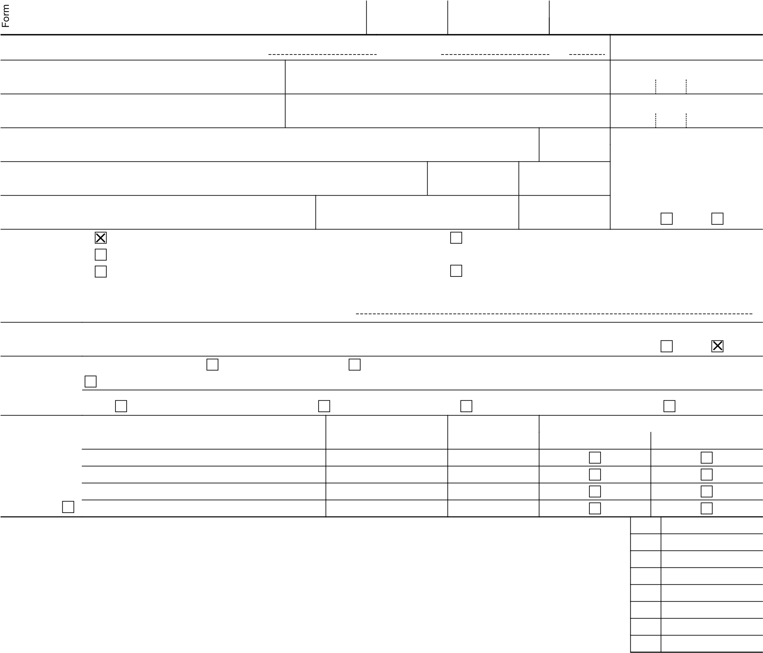If you checked the MFS box, enter the name of your spouse. If you checked the HOH or QSS box, enter the child’s name if the qualifying person is a child but not your dependent: Digital At any time during 2023, did you: (a) receive (as a reward, award, or payment for property or services); or (b) sell,

Assets exchange, or otherwise dispose of a digital asset (or a financial interest in a digital asset)? (See instructions.) Yes No

Standard Someone can claim: You as a dependent Your spouse as a dependent

Deduction Spouse itemizes on a separate return or you were a dual-status alien

Age/Blindness You: Were born before January 2, 1959 Are blind Spouse: Was born before January 2, 1959 Is blind

Dependents (see instructions): (2) Social security (3) Relationship (4) Check the box if qualifies for (see instructions):

(1) First name Last name number to you Child tax credit Credit for other dependents

If more than four dependents, see instructions

and check here . .

Income 1a Total amount from Form(s) W-2, box 1 (see instructions) . . . . . . . . . . . . . 1a 26,000. b Household employee wages not reported on Form(s) W-2 . . . . . . . . . . . . . 1b

Attach Form(s)

W-2 here. Also c Tip income not reported on line 1a (see instructions) . . . . . . . . . . . . . . 1c attach Forms d Medicaid waiver payments not reported on Form(s) W-2 (see instructions) . . . . . . . . 1d W-2G and

1099-R if tax e Taxable dependent care benefits from Form 2441, line 26 . . . . . . . . . . . . 1e was withheld. f Employer-provided adoption benefits from Form 8839, line 29 . . . . . . . . . . . 1f

If you did not get a Form

W-2, see 0. instructions.

z Add lines 1a through 1h . . . . . . . . . . . . . .

Attach Sch. B 2a Tax-exempt interest . . . if required. 3a Qualified dividends . . . 4a IRA distributions . . . . 5a Pensions and annuities . . 6a Social security benefits . .

Married filing

separately, c If you elect to use the lump-sum election method, check here (see instructions)

$13,850 7 Capital gain or (loss). Attach Schedule D if required. If not required, check here jointly or 8 Additional income from Schedule 1, line 10 . . . . . .

Qualifying 9 Add lines 1z, 2b, 3b, 4b, 5b, 6b, 7, and 8. This is your total income . surviving spouse,

$27,700 10 Adjustments to income from Schedule 1, line 26 . . . .

household, 11 Subtract line 10 from line 9. This is your adjusted gross income $20,800 12 Standard deduction or itemized deductions (from Schedule A) any box under 13 Qualified business income deduction from Form 8995 or Form 8995-A .

Standard

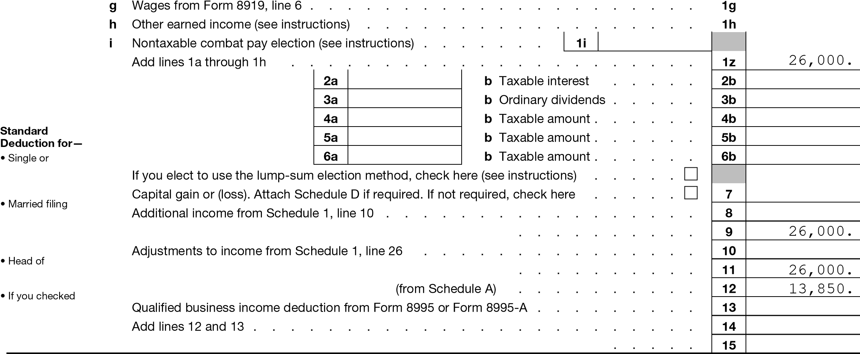Deduction, 14 Add lines 12 and 13 . . . . . . . . . . . . . 13,850. see instructions. 15 Subtract line 14 from line 11. If zero or less, enter -0-. This is your taxable income . 12,150.

For Disclosure, Privacy Act, and Paperwork Reduction Act Notice, see separate instructions. Form 1040 (2023)

Form 1040 (2023)

Tax and

Credits

Payments

If you have a qualifying child, attach Sch. EIC.

Refund

Direct deposit?

See instructions.

Amount You Owe

Third Party Designee

Sign Here

Joint return?

See instructions. Keep a copy for your records.

Paid

Preparer

Use Only

Page 2

1. Tax (see instructions). Check if any from Form(s): 1 8814 2 4972 3 . . 16 1,241.
2. Amount from Schedule 2, line 3 . . . . . . . . . . . . . . . . . . . . 17
3. Add lines 16 and 17 . . . . . . . . . . . . . . . . . . . . . . . . 18 1,241.
4. Child tax credit or credit for other dependents from Schedule 8812 . . . . . . . . . . 19
5. Amount from Schedule 3, line 8 . . . . . . . . . . . . . . . . . . . . 20 21 Add lines 19 and 20 . . . . . . . . . . . . . . . . . . . . . . . . 21

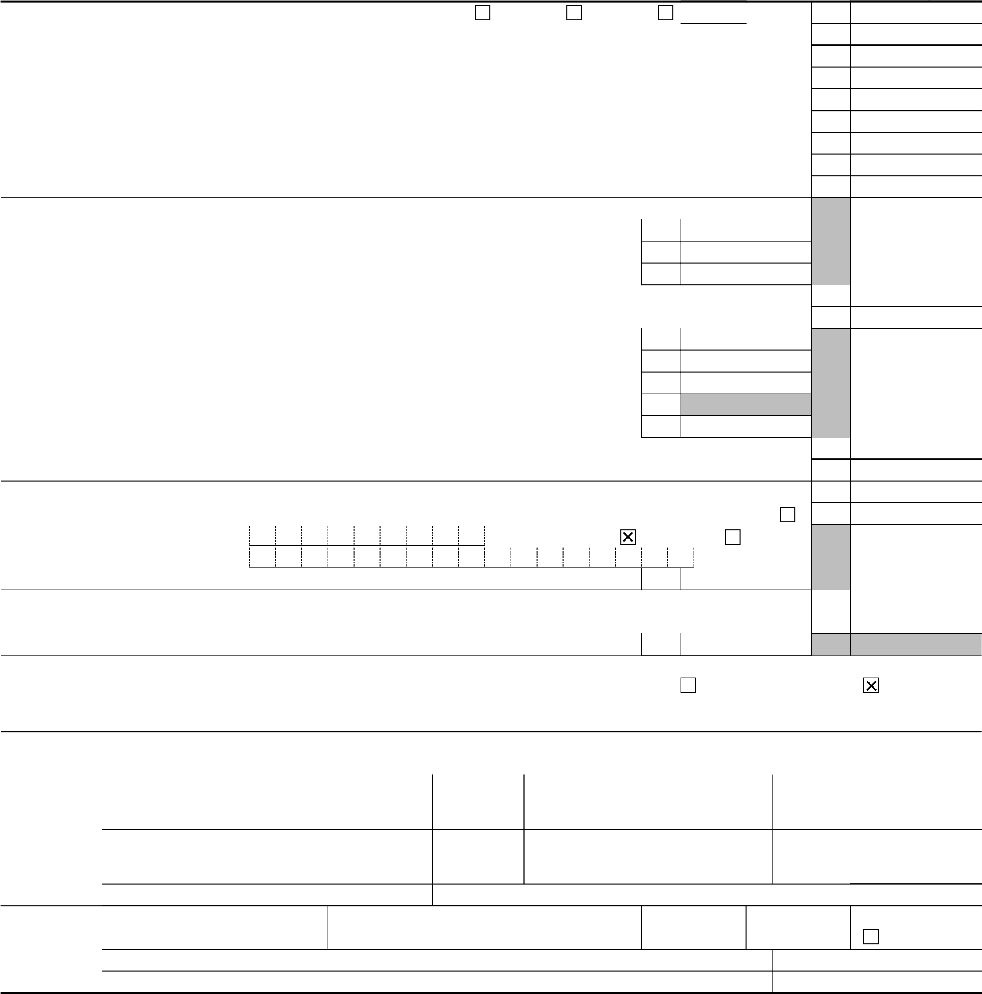22 Subtract line 21 from line 18. If zero or less, enter -0- . . . . . . . . . . . . . . 22 1,241. 23 Other taxes, including self-employment tax, from Schedule 2, line 21 . . . . . . . . . 23 0. 24 Add lines 22 and 23. This is your total tax . . . . . . . . . . . . . . . . . 24 1,241.

25 Federal income tax withheld from: a Form(s) W-2 . . . . . . . . . . . . . . . . . . 25a 2,270.

b Form(s) 1099 . . . . . . . . . . . . . . . . . . 25b c Other forms (see instructions) . . . . . . . . . . . . . 25c d Add lines 25a through 25c . . . . . . . . . . . . . . . . . . . . . . 25d 2,270.

1. 2023 estimated tax payments and amount applied from 2022 return . . . . . . . . . . 26
2. Earned income credit (EIC) . . . . . . . . . . . .No. . 27
3. Additional child tax credit from Schedule 8812 . . . . . . . . 28
4. American opportunity credit from Form 8863, line 8 . . . . . . . 29
5. Reserved for future use . . . . . . . . . . . . . . . 30
6. Amount from Schedule 3, line 15 . . . . . . . . . . . . 31
7. Add lines 27, 28, 29, and 31. These are your total other payments and refundable credits . . 32
8. Add lines 25d, 26, and 32. These are your total payments . . . . . . . . . . . . 33 2,270.
9. If line 33 is more than line 24, subtract line 24 from line 33. This is the amount you overpaid . . 34 1,029. 35a Amount of line 34 you want refunded to you. If Form 8888 is attached, check here . . . . 35a 1,029. b Routing number 0 2 1 2 0 0 3 3 9 c Type: Checking Savings

# d Account number 3 8 1 0 5 5 3 9 8 2 7 9

1. Amount of line 34 you want applied to your 2024 estimated tax . . . 36
2. Subtract line 33 from line 24. This is the amount you owe.

For details on how to pay, go to www.irs.gov/Payments or see instructions . . . . . . . . 37

1. Estimated tax penalty (see instructions) . . . . . . . . . . 38

Do you want to allow another person to discuss this return with the IRS? See

instructions . . . . . . . . . . . . . . . . . . . . . Yes. Complete below. No

Designee’s Phone Personal identification

name no. number (PIN)

Under penalties of perjury, I declare that I have examined this return and accompanying schedules and statements, and to the best of my knowledge and belief, they are true, correct, and complete. Declaration of preparer (other than taxpayer) is based on all information of which preparer has any knowledge.

Your signature Date Your occupation If the IRS sent you an Identity

Protection PIN, enter it here

PIZZA MAN (see inst.)

Spouse’s signature. If a joint return, both must sign. Date Spouse’s occupation If the IRS sent your spouse an

Identity Protection PIN, enter it here

(see inst.)

Phone no. (201)936-3539 Email address KAMAL271989@GMAIL.COM

Preparer’s name Preparer’s signature Date PTIN Check if:

# VENKATA SAI PAVAN KUMAR DUDIPALLI VENKATA SAI PAVAN KUMAR DUDIPALLI P02470833 Self-employed Firm’s name GLOBAL TAXES LLC Phone no. (678)965-9522 Firm’s address 245 ROONEY CT E BRUNSWICK NJ 08816 Firm’s EIN 88-2145487

Go to www.irs.gov/Form1040 for instructions and the latest information. BAA REV 02/23/24 PRO Form 1040 (2023)

## 2023 NJ-1040

New Jersey Resident Income Tax Return

For Privacy Act Notification, See Instructions

1555

# 040MP01230

Your Social Security Number (required)  Last Name, First Name, Initial (Joint Filers enter first name and middle initial of each. Enter spouse’s/CU partner’s last name ONLY if different.)

## 676534104 GUNASEKARAN KAMALAKANNAN

Spouse’s/CU Partner’s SSN (if filing jointly)

Home Address (Number and Street, including apartment number) County/Municipality Code (See Table page 50) 111 MULBERRY STREET RENNA APT 10

0702

City, Town, Post Office State ZIP Code

NEWARK NJ 07102

Driver’s License Number (Voluntary) (See instructions)

## G92574240007892

Federal extension filed.

The address above is a foreign address.

Your address has changed.

Death certificate is enclosed.

Do not want a paper form next year.

I authorize the Division of Taxation to discuss my return and enclosures with my preparer.

NJ-1040-O is enclosed.

|  |  |  |  |  |
| --- | --- | --- | --- | --- |
| Gubernatorial Elections Fund Note: This does not reduce your refund or increase your balance due.  Do you want to designate $1 to the Gubernatorial Elections Fund? You  If joint return, does your spouse want to designate $1? Spouse/CU Partner    Direct Deposit Information  dd1. Direct deposit indicator (1 for direct deposit, 4 for no direct deposit) dd2. Account type (C for checking, S for savings) dd3. Fill in the checkbox if the direct deposit is going to an account outside the United States dd4. Routing number dd5. Account number | dd1. 1 dd2. C dd3. dd4. dd5. | Yes  Yes |  | No No      021200339 |
| 381055398279 | | |



Name(s) as shown on Form NJ-1040

## GUNASEKARAN KAMALAKANNAN

Your Social Security Number

676534104 1555

# 040MP02230

Part-year residents, provide months/days you were a New Jersey resident during 2023: Fiscal year filers only:

From: To: Enter month of your year end 2 02 4

FillFilingin onlyStatusone.

## 1. Single

1. Married/CU Couple, filing joint return
2. Married/CU Partner, filing separate return

4. Head of Household Enter spouse’s/CU partner’s SSN

5. Qualifying Widow(er)/Surviving CU Partner

Indicate the year of your spouse’s/CU partner’s death: 2021 2022

FillExemptionsin the ovals that apply. You must enter a total in the boxes to the right and complete the calculation.

|  |  |  |  |  |  |
| --- | --- | --- | --- | --- | --- |
| 6.  7.  8. 9.  10. 11. | Regular  Senior 65+ (Born in 1958 or earlier)  Blind/Disabled Veteran  Qualified Dependent Children Other Dependents | Self  Self  Self  Self | Spouse/CU Partner  Spouse/CU Partner Spouse/CU Partner Spouse/CU Partner | Domestic Partner | 1 |

1. Dependents Attending Colleges (See instructions)
2. Total Exemption Amount (Add totals from the lines at 6 through 12)

x $1,000 = _________1000 x $1,000 = _________ x $1,000 = _________ x $6,000 = _________ x $1,500 = _________ x $1,500 = _________

x $1,000 = _________

13. 1000 .

14. Dependent Information. Provide the following information for each dependent.

Last Name, First Name, Middle Initial Social Security Number Birth Year No Health Insurance a. _________________________________________________________________

1. _________________________________________________________________
2. _________________________________________________________________
3. _________________________________________________________________

Name(s) as shown on Form NJ-1040

## GUNASEKARAN KAMALAKANNAN

Your Social Security Number

676534104 1555

# 040MP03230

15. Wages, salaries, tips, and other employee compensation (State wages from Box 16 of enclosed W-2(s)) (See instructions) 15. 26000 . 16a. Taxable interest income (Enclose federal Schedule B if over $1,500) (See instructions) 16a. . 16b. Tax-exempt interest income (Enclose Schedule) (See instructions) Do not include on line 16a 16b. .

1. Dividends 17. .
2. Net profits from business (Schedule NJ-BUS-1, Part I, line 4) (Enclose federal Schedule C) 18. . 19. Net gains or income from disposition of property (Schedule NJ-DOP, line 4) 19. .

20a. Taxable pensions, annuities, and IRA distributions/withdrawals (See instructions) 20a. .

20b. Excludable pension, annuity, and IRA distributions/withdrawals 20b. .

1. Distributive Share of Partnership Income (Schedule NJ-BUS-1, Part II, line 4) (Enclose Schedule NJK-1 or federal Schedule K-1) 21. .
2. Net pro rata share of S Corporation Income (Schedule NJ-BUS-1, Part III, line 4) (Enclose Schedule NJ-K-1 or federal Schedule K-1) 22. . 23. Net gains or income from rents, royalties, patents, and copyrights (Schedule NJ-BUS-1, Part IV, line 4) 23. .

24. Net gambling winnings (See instructions) 24. . 25. Alimony and separate maintenance payments received 25. . 26. Other (Enclose documents) (See instructions) 26. .

27. Total Income (Add lines 15, 16a, 17 through 20a, and 21 through 26) 27. 26000 . 28a. Pension/Retirement Exclusion (See instructions) 28a. .

28b. Other Retirement Income Exclusion (See Worksheet D and instructions pages 19-20) 28b. .

28c. Total Exclusion Amount (Add lines 28a and 28b) 28c. .

29. New Jersey Gross Income (Subtract line 28c from line 27) (See instructions) 29. 26000 . 30. Exemption Amount (Enter amount from line 13. Part-year residents see instr.) 30. 1000 .

31. Medical Expenses (See Worksheet F and instructions) 31. . 32. Alimony and separate maintenance payments (See instructions) 32. .

33. Qualified Conservation Contribution 33. . 34. Health Enterprise Zone Deduction 34. .

35. Alternative Business Calculation Adjustment (Schedule NJ-BUS-2, line 11) 35. 0 . 36. Organ/Bone Marrow Donation Deduction (See instructions) 36. . 37a. NJBEST Deduction 37a. .

37b. NJCLASS Deduction 37b. .

37c. NJ Higher Ed. Tuition Deduction 37c. .

38. Total Exemptions and Deductions (Add lines 30 through 37c) 38. 1000 . 39. Taxable Income (Subtract line 38 from line 29) 39. 25000 .

40a. Total Property Taxes (18% of Rent) Paid (See instructions page 25) 40a. .

40b. Indicate your residency status during 2023 (fill in only one) Homeowner Tenant

1. Property Tax Deduction (From Worksheet H) (See instructions)
2. New Jersey Taxable Income (Subtract line 41 from line 39)
3. Tax on amount on line 42 (Tax Table page 52)
4. Credit For Income Taxes Paid to Other Jurisdictions (Enclose Schedule NJ-COJ) (See instructions)

Enter Code

1. Balance of Tax (Subtract line 44 from line 43)
2. Sheltered Workshop Tax Credit
3. Gold Star Family Counseling Credit (See instructions)
4. Credit for Employer of Organ/Bone Marrow Donor (See instructions)
5. Total Credits (Add lines 46 through 48)
6. Balance of Tax After Credits (Subtract line 49 from line 45) If zero or less, make no entry
7. Use Tax Due on Internet, Mail-Order, or Other Out-of-State Purchases (See instructions) If no Use Tax, enter 0
8. Interest on Underpayment of Estimated Tax

Fill in if Form NJ-2210 is enclosed

53a. Fill in if anyone in your tax household does not currently have health insurance. (Enclose NJ-EZ Enroll form) (See instructions)

Both

1. .
2. 25000 . 43. 368 .
3. .

1. 368 .
2. .
3. .
4. .
5. .
6. 368 .
7. 0 . 52. .

53a.

Name(s) as shown on Form NJ-1040

GUNASEKARAN KAMALAKANNAN

Your Social Security Number

676534104 1555

# 040MP04230

53b. If you indicated at line 53a that someone in your tax household does not have health insurance, fill in to allow 53b.

Get Covered New Jersey to assist with obtaining coverage (See instructions)

53c. Shared Responsibility Payment (See instructions) REQUIRED Enclose Schedule NJ-HCC and fill in53c. 0 . 368 . 420 . .

.

.

.

.

.

.

.

.

.

420 . .

1. Total Tax Due (Add lines 50 through 53c) 54.
2. Total NJ Income Tax Withheld (Enclose Forms W-2 and 1099) (Part-year residents, see instructions) 55.
3. Property Tax Credit (See instructions page 24) 56.
4. New Jersey Estimated Tax Payments/Credit from 2022 tax return 57. 58. New Jersey Earned Income Tax Credit (See instructions) 58.

Fill in if you had the IRS calculate your federal earned income credit

Fill in if you are a CU couple claiming the NJ Earned Income Tax Credit

59. Excess New Jersey UI/WF/SWF Withheld (Enclose Form NJ-2450) (See instructions) 59. 60. Excess New Jersey Disability Insurance Withheld (Enclose Form NJ-2450) (See instructions) 60.

1. Excess New Jersey Family Leave Insurance Withheld (Enclose Form NJ-2450) (See instructions) 61.
2. Wounded Warrior Caregivers Credit (See instructions) 62.
3. Pass-Through Business Alternative Income Tax Credit (See instructions) 63.
4. Child and Dependent Care Credit (See instructions) 64. Fill in if you are a CU couple claiming the Child and Dependent Care Credit
5. New Jersey Child Tax Credit (See instructions) 65. Number of dependents age 5 or younger on 12/31/2023
6. Total Withholdings, Credits, and Payments (Add lines 55 through 65) 66.
7. If line 66 is less than line 54, you have tax due. Subtract line 66 from line 54 and enter the amount you owe 67.

If you owe tax, you can still make a donation on lines 70 through 77.

1. If the total on line 66 is more than line 54, you have an overpayment. Subtract line 54 from line 66 and enter the overpayment 68. 52 .
2. Amount from line 68 you want to credit to your 2024 tax 69. . 70. Contribution to N.J. Endangered Wildlife Fund 70. .

71. Contribution to N.J. Children’s Trust Fund to Prevent Child Abuse 71. .

1. Contribution to N.J. Vietnam Veterans’ Memorial Fund 72. .
2. Contribution to N.J. Breast Cancer Research Fund 73. .

74. Contribution to U.S.S. New Jersey Educational Museum Fund 74. .

1. Other Designated Contribution (See instructions) Enter Code 75. .

|  |  |  |
| --- | --- | --- |
| 1. Other Designated Contribution (See instructions) Enter Code 2. Total Adjustments to Tax Due/Overpayment amount (Add lines 69 through 77) 3. Balance due (If line 67 is more than zero, add line 67 and line 78)   80. Refund amount (If line 68 is more than zero, subtract line 78 from line 68) | 77.  78.  79.  80. | . .  .  52 . |

1. Other Designated Contribution (See instructions) Enter Code 76. .

|  |  |  |
| --- | --- | --- |
| Under penalties of perjury, I declare that I have examined this Income Tax return, including accompanying schedules and statements, and to the best of my knowledge and belief, it is true, correct, and complete. If prepared by a person other than the taxpayer, this declaration is based on all information of which the preparer has any knowledge. | | Tax Due Address  Enclose payment along with the NJ-1040-V payment voucher and tax return. Use the labels provided with the envelope and mail to:  State of New Jersey  Division of Taxation |
| Your Signature Date Spouse’s/CU Partner’s Signature (required if filing jointly) Date | | Revenue Processing Center - Payments  PO Box 111  Trenton, NJ 08645-0111  Include Social Security number and make check or money order payable to:  State of New Jersey – TGI  You can also make a payment on our website: nj.gov/taxation  Refund or No Tax Due Address  Use the labels provided with the envelope and mail to:  New Jersey Division of Taxation  Revenue Processing Center - Refunds  PO Box 555  Trenton, NJ 08647-0555 |
| Paid Preparer's Signature    VENKATA SAI PAVAN KUMAR DUDIPALLI | Federal Identification Number  P02470833 |
| Firm's Name  GLOBAL TAXES LLC | Firm’s Federal Employer Identification Number  88-2145487 |

Division Use: 1 _______________ 2 _______________ 3 _______________ 4 _______________ 5 _______________ 6 _______________ 7 _______________

5(48,5(' IfPyourVW submitincomethisonscheduleline 29 iswithaboveyourthereturn.ling threshold, you

|  |  |  |
| --- | --- | --- |
| Name(s) as shown on Form NJ-1040 |  | Social Security Number |
| GUNASEKARAN KAMALAKANNAN | 676-53-4104 |  |

## 6FKHG OH 1- Health Care Coverage

If your income on line 29 is at or below the ling threshold (see instructions), do not complete this schedule.

|  |  |  |  |  |  |  |  |  |  |  |  |  |  |  |  |  |  |  |  |  |  |  |  |  |  |
| --- | --- | --- | --- | --- | --- | --- | --- | --- | --- | --- | --- | --- | --- | --- | --- | --- | --- | --- | --- | --- | --- | --- | --- | --- | --- |
| 3DUW , | | | | | | | | | | | | | | | | | | | | | | | | | |
| Did you and, if applicable, all members of your tax household, have minimum essential health coverage for every month in 2023? (See instructions for line 53c, NJ-1040.) Part-year residents include only months as a New Jersey resident. Yes. You do not owe a shared responsibility payment. Fill in the oval at line 53c, NJ-1040, and enclose this schedule with your return. No. Continue to Part II.  If you or any member of your tax household does not F UUHQWO have minimum essential health coverage, also complete the NJ-EZ Enroll form. (See instructions for lines 53a and 53b, NJ-1040.) | | | | | | | | | | | | | | | | | | | | | | | | | |
| 3DUW ,, | | | | | | | | | | | | | | | | | | | | | | | | | |
| Enter the name and Social Security number for each member of your tax household. heck the box for every month each person had minimum essential health coverage or quali ed for an exemption (part-year residents include only months as a New Jersey resident). If an individual quali ed for an exemption, enter the exemption number. (See instructions for line 53c, NJ-1040.) If an individual has more than one exemption number, check the box. If you need more space, enclose a statement listing any additional individuals. | | | | | | | | | | | | | | | | | | | | | | | | | |
|  | | Jan | | E | | Mar | | Apr | | May | | Jun | | Jul | | Aug | | 6 S | | Oct | | 1 | | Dec | |
| Name Social Security Number | |  | |  | |  | |  | |  | |  | |  | |  | |  | |  | |  | |  | |
| |  |  |  |  |  |  |  |  |  |  |  | | --- | --- | --- | --- | --- | --- | --- | --- | --- | --- | --- | |  |  |  |  |  |  |  |  |  |  |  |   Exemption number: Check box if this individual has more than one exemption number | | | | | | | | | | | | | | | | | | | | | | | | | |
|  | | Jan | | E | | Mar | | Apr | | May | | Jun | | Jul | | Aug | | 6 S | | Oct | | 1 | | Dec | |
| Name Social Security Number | |  | |  | |  | |  | |  | |  | |  | |  | |  | |  | |  | |  | |
| |  |  |  |  |  |  |  |  | | --- | --- | --- | --- | --- | --- | --- | --- | |  |  |  |  |  |  |  |  |   Exemption number: | | |  |  |  | | --- | --- | --- | |  |  |  |   Check box if this individual has more than one exemption number | | | | | | | | | | | | | | | | | | | | | | | |
|  | | Jan | | E | | Mar | | Apr | | May | | Jun | | Jul | | Aug | | 6 S | | Oct | | 1 | | Dec | |
| Name Social Security Number | |  | |  | |  | |  | |  | |  | |  | |  | |  | |  | |  | |  | |
| |  |  |  |  |  |  |  |  | | --- | --- | --- | --- | --- | --- | --- | --- | |  |  |  |  |  |  |  |  |   Exemption number: | | |  |  |  | | --- | --- | --- | |  |  |  |   Check box if this individual has more than one exemption number | | | | | | | | | | | | | | | | | | | | | | | |
|  | | Jan | | E | | Mar | | Apr | | May | | Jun | | Jul | | Aug | | 6 S | | Oct | | 1 | | Dec | |
| Name Social Security Number | |  | |  | |  | |  | |  | |  | |  | |  | |  | |  | |  | |  | |
| |  |  |  |  |  |  |  |  | | --- | --- | --- | --- | --- | --- | --- | --- | |  |  |  |  |  |  |  |  |   Exemption number: | | |  |  |  | | --- | --- | --- | |  |  |  |   Check box if this individual has more than one exemption number | | | | | | | | | | | | | | | | | | | | | | | |

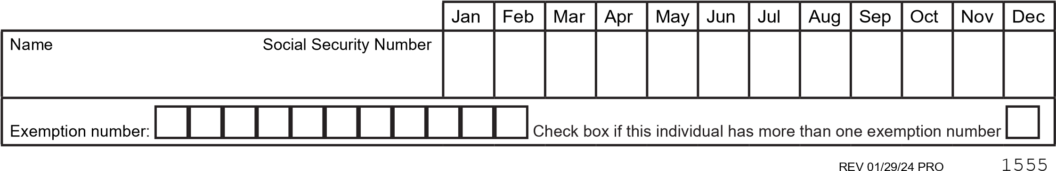

.HHS D FRS RI WKLV VFKHG OH IRU R U UHFRUGV