1. Last name: SAJJA
2. Middle name:
3. First name: NARENDRA
4. Occupation: SAP CONSULTANT
5. DOB: 11th July 1992 or 07/11/1992
6. Email id: SAJJANARENDRA369@GMAIL.COM
7. Contact no: +13619030903
8. Current address: 1200 RIO VISTA BLVD APT 106, PALM BEACH GARDENS
9. Marital status on 31st Dec 2023: SINGLE
10. Visa status on 31st Dec 2023: H1B Visa
11. No of months stayed in US in the year 2023: 12
12. State lived in US in 2023(mention name & date if lived more than one state): Florida, Palm Beach Gardens
13. Any Advance child tax credit amount received in 2023: None
14. Any loans in India or USA: Yes Car Loan
15.First port of entry date (year) to USA :10th Jan 2014 (Masters TAMUK university)
Travel history as provided below based on I94 copy
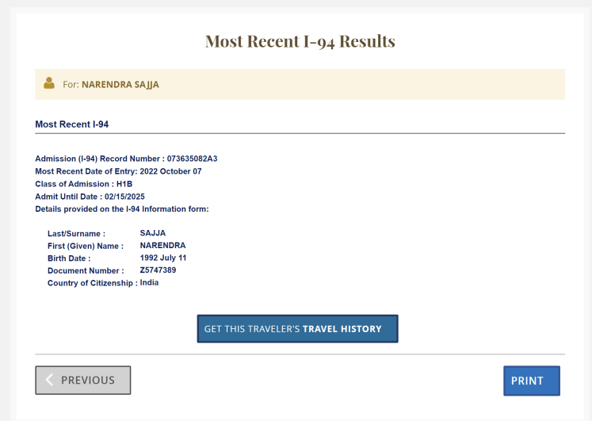
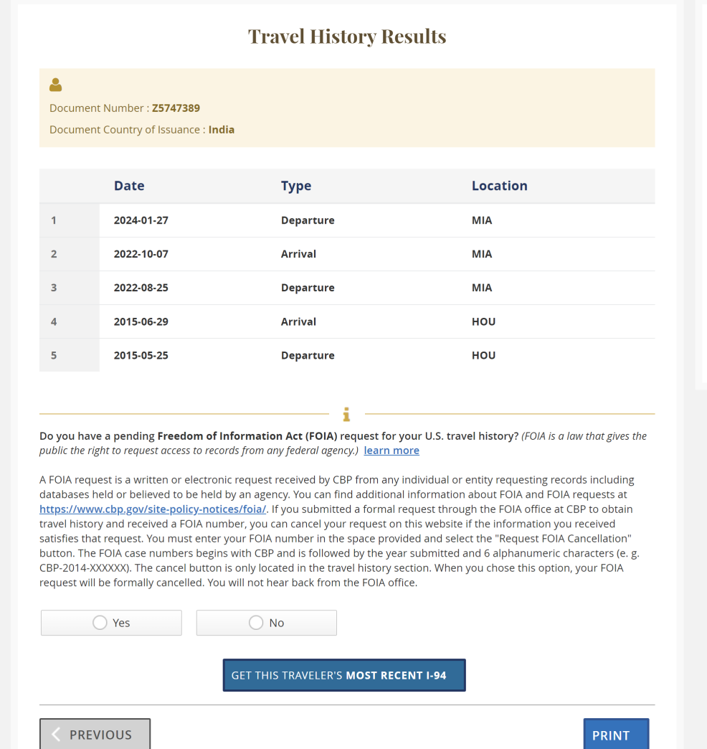

16. SSN: 896269280
Spouse Details
1. First name:
2.Last name:
3. ITIN/SSN:
4. DOB:
5. Occupation:
Kids Details
1. First name:
2.Last name:
3. ITIN/SSN:
4. DOB:
5.Amount received as child tax credit in 2023

