1. Last name: SANNIDHI

2. Middle name:

3. First name: AYYAPPA SAI KUMAR

4. Occupation: STUDENT (now my opt started on jan 2024)

5. DOB: 01 -04-1999 ( MM/DD/YYYY) Jan 4 1999

6. Email id: AYYAPPASANNIDHI7@GMAIL.COM

7. Contact no: 8135770785

8. Current address: 465 BUCKLAND HILL DRIVE MANCHESTER CONNECTICUT, 06042

9. Marital status on 31st Dec 2023: not married

10. Visa status on 31st Dec 2023 : F-1

11. No of months stayed in US in the year 2023:

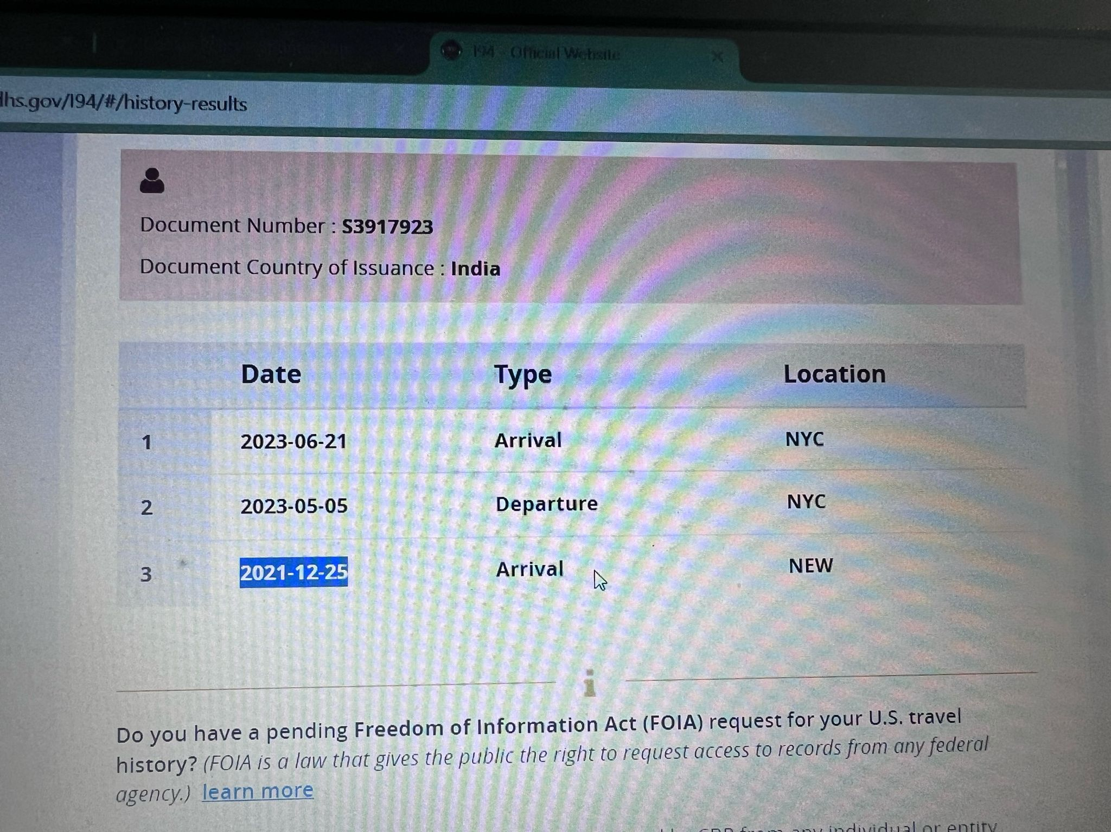

First Port of entry: 12-25-2021

Went to india : 05-05-2023

cam back to usa : 21--06-2023

12. State lived in US in 2023(mention name & date if lived more than one state):

OH- 2023

13. Any Advance child tax credit amount received in 2023: no

14. Any loans in India or USA: no

15.First port of entry date (year) to USA : 12-25-2023

16. SSN: 677-93-2517