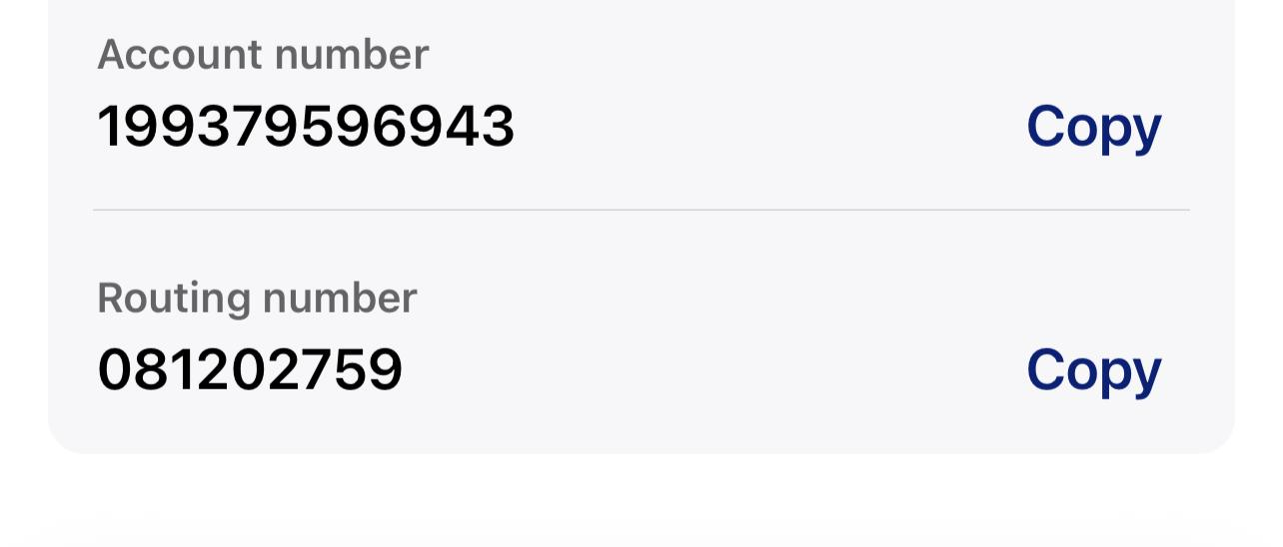

Checking account

US BANK

Varun Krishna Konduru