|  |  |
| --- | --- |
| **Bank Name** | PNC bank |
| **Routing Number (Paper/Electronic)** | 071921891 |
| **Account Number** | 4668357577 |
| **Checking / Saving Account** | Checking account |
| **Account Holder** | Monica Satyani |

Driving license copy: attached

India address: 17-5-3, pallapu street, west godavari, palakol - 534260

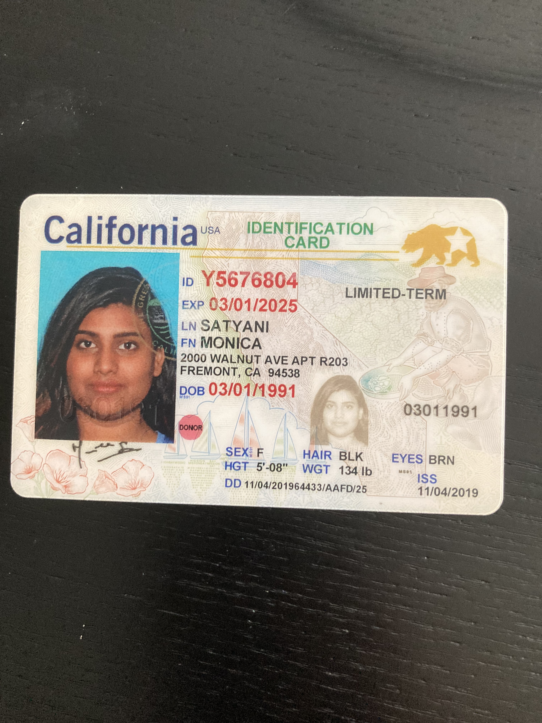

US CURRENT ADRESS: 4610 margery drive, fremont, ca - 94538