**IPHONE;**

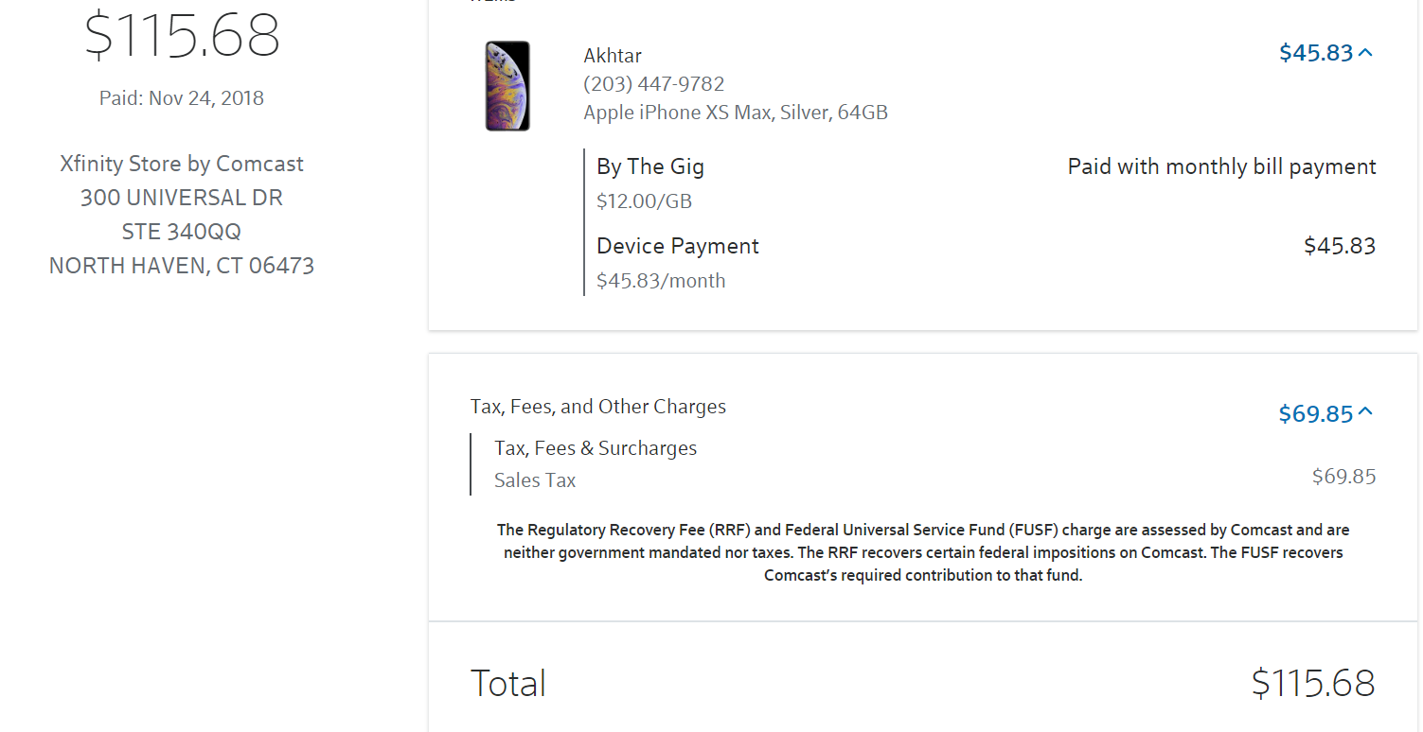

**TV;**

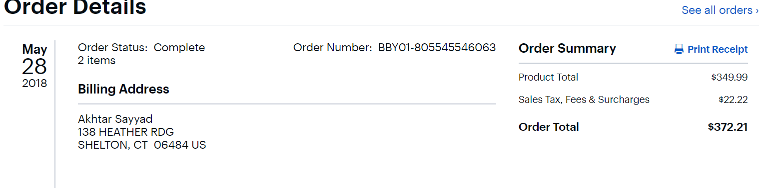

Car;

|  |  |
| --- | --- |
| ***Is this a Hybrid or Alternative Motor Vehicle?*** | ***No*** |
| ***Make & Model of the Vehicle*** | Volkswagen Passat |
| ***Purchase Date*** | *May 11, 2018* |
| ***Cost Price*** | ***$14003*** |
| ***Total Mileage during TY 2016*** | ***32000*** |
| ***Sales & Excise Tax paid on the vehicle bought in TY 2016*** | ***$901*** |